Student Project Showcase Manual
Celebrating and Demostrating 8th Grade Positive Purpose Projects (8th Grade PPP) and 6th and 7th Grade Students Taking Action Together (STAT) Projects.
Rutgers Social-Emotional and Character Development Lab (secdlab@gmail.com)
For more information:
www.secdlab.org

Table of Contents
Student Project Showcase Overview 3
Sample Timeline for 8th Grade Positive Purpose Project Showcase 7
Sample Timeline for 6th and 7th Grade STAT Showcase 10
Sample Showcase Materials and Considerations 13
Sample Full-Day Agenda 14
Sample Half-Day Agenda 15
Sample Evening Showcase Agenda 16
Sample Showcase Set Up Checklist (General) 17
Arrival Considerations 18
Welcome Speech Considerations 22
Mindfulness Activity Scripts 23
Project Presentation Considerations 24
Sample Showcase Project Presentation Script 25
Food Considerations 26
Award Considerations 27
SAMPLE CERTIFICATE 28
Sample Award Scripts 29
Closing and Dismissal Considerations 30
Sample MOSAIC Ambassador Pledge 31
Project Fair (Optional) Considerations 32
Sample Project Fair Instructions 33
Sample Project Fair Passport 34
Student Project Fair Booths 35
Note Instructions 36
Guest Speaker/Q & A Panel (Optional) Considerations 37
Additional (Optional) Activity Ideas 38
Case Example: Full-Day 8th Grade PPP Showcase with Multiple Schools held at a Public University 39
Case Example Full-Day 8th Grade PPP Showcase Detailed Script 40
Sample Showcase Materials Checklist 49
Sample PowerPoint Slides: 50
Concluding Thoughts 51

Student Project Showcase Overview

6th and 7th Grade Students Taking Action Together (STAT) Projects Showcase:
- STAT Projects are completed by 6th and 7th grade Ambassadors and their classmates. The MOSAIC classrooms engage in monthly planning and discussions that are led by the Ambassadors. The classrooms carry out the project outside of the MOSAIC class time. The 6th and 7th Grade STAT projects tend to be smaller in scope than 8th Grade PPPs. Each class is likely to have one or two STAT Projects in a given school year.
- 6th and 7th Grade STAT Showcases involve more students than 8th Grade PPP Showcases, since they include students from all 6th and 7th grade classrooms. They can be much smaller in scope and may be integrated into other existing events, such as a school assembly, field day, parents’ night, back to school night, or orientation for 5th graders.
- Here are a few examples of 6th Grade STAT Projects:
  - Structure to make sure that all the students in their class have someone to sit with during lunch and invite those who sit alone to join them.
  - Initiative to reach out to the student coordinators of the school newspaper and ask them to add an article about the opportunities at their school.
  - Helping to begin a mentorship program where each 6th grade student in their class is assigned an 8th grade buddy.
- Here are a few examples of 7th Grade STAT Projects:
  - Class research to make a list of academic help resources in their school and community to be posted on bulletin boards in well-trafficked hallways.
  - Class research to understand what healthy nutrition for middle schoolers look like and what other schools have done to improve their food options and propose a similar option for their school.
8th Grade Positive Purpose Project (PPP) Showcase:
- 8th Grade PPPs are completed by 8th grade Ambassadors outside of the MOSAIC Curriculum structure. The Ambassadors receive input from their classmates, but largely create the project with minimal formal connection to MOSAIC. These projects typically are school-wide in scope or may involve the larger community.
- 8th Grade PPP Showcases can be more elaborate than 6th and 7th Grade STAT Showcases because they involve a smaller group of students. It is possible to bring together 8th Grade PPP teams from multiple schools into a single school or at an off-campus location (a local college, university, or community organization), as well as to create a school-community event around the 8th Grade PPP Showcase.
- Here are a few examples of 8th Grade Positive Purpose Projects:
  - Anti-Bullying Campaign: Ambassadors who see bullying happening around school might launch an anti-bullying initiative by creating posters to hang up around the school and presenting on bullying during an assembly.
  - A Friendly, Caring School: Ambassadors who see students who are new, alone, rejected, bullied take steps to reach out and include them. This may also include ideas for how to be more welcoming and friendly, such as greeting people, opening doors for others, helping people carry heavy or many things, finding other ways to provide help to students where needed.
  - Beautify the School Campaign: Ambassadors who see students leaving garbage on the floors, in hallways and classrooms might choose to work on a school beautification project. This may include presentations about recycling and keeping the hallways clean, or hosting a hallway-decorating event where students can come to decorate bulletin boards.
  - Ambassador Team Tutoring: Ambassadors notice that some of the 6th graders struggle with math, but don’t have anyone they can go to. These Ambassadors recruit 8th graders who are good at math and start a weekly tutoring day where 6th graders can get help from 8th graders after school.
  - School Newspaper: Ambassadors start a school newspaper to share good things that are happening in the school, both within the school and outside the school.
  - Multicultural Awareness: A lot of students see a need for students and teachers to learn about and appreciate cultures that are different from their own. This can be done through videos, posters, game nights, creating a bazaar, assemblies, etc.
- See the MOSAIC website: www.secdlab.org/ambassadors for a video demonstrating previous Ambassador showcase events at Rutgers University.
General Showcase Guidelines and Principles
The 6th and 7th Grade STAT or 8th Grade PPP Showcase is designed for Ambassadors (or other student leaders) to demonstrate what they have learned through their 8th Grade Positive Purpose Project (PPP) or Students Taking Action Together (STAT) Projects.
Depending on the size of the school and scope of 6th and 7th Grade STAT Projects and 8th Grade PPPs, schools may decide to combine the 8th Grade PPP and 6th and 7th Grade STAT Showcase or decide to hold separate events.
The 8th Grade PPP and/or 6th and 7th Grade STAT Showcase(s) can be presented by Ambassadors only or by Ambassadors and their classmates. For example, schools can have the 8th Grade PPP Showcase presented by 8th grade Ambassadors only and presentation of the 6th and 7th Grade STAT showcase could include wider representation of the study body (all 6th and 7th graders). Alternatively, the 6th and 7th Grade STAT and 8th Grade PPP Showcase could be one event presented by only the 6th, 7th, and 8th grade Ambassadors.
Regardless of scope and format, the 6th and 7th Grade STAT and 8th Grade PPP Showcases should aim to share the same goals:
1) Consolidating student learning,
2) Acknowledging student effort,
3) Inspiring others, and
4) Fostering community.
To meet these goals, there are a few requirements for the Showcase:
- Encourage student representation: It is important that all students who participated in the projects have some kind of representation- direct or indirect- at the showcase and are involved in the preparation. The act of making the presentations is an important part of the learning process for the students, and so is being acknowledged for participating. Preparing for and doing the Showcase builds many social-emotional and character competencies.
- Provide formal acknowledgement: Students should be provided some kind of formal acknowledgment for their projects. Whether this is a formal award or a certificate of participation may depend on the nature of the project and the Showcase.
- Create an audience: It is important that the Showcase is presented to a larger audience than students’ own classrooms. This could be the entire school, younger students, an interschool assembly of Ambassadors, or parents or community members. When Showcases go well, they can be inspiring. They can inspire younger students to want to get involved in STAT and student leadership. They also can inspire community members and groups, as well as parents, to get more involved in supporting school projects, particularly those with a community improvement orientation. Through this demonstration process, the Showcase also builds community across the presenters and the Showcase audience.

Decisions Schools Should Make about Showcases:
- Will 6th and 7th Grade STAT and 8th Grade PPP Showcases be held separately or combined?
- Who will present in the 6th and 7th Grade STAT Showcase? (All 6th/7th students or just Ambassadors?)
- Who will plan the 6th and 7th Grade STAT Showcase? (It is recommended to have a designated point person and committee of school members)
- Who will plan the 8th Grade PPP Showcase? (It is recommended to have a designated point person and committee of school members)
- How will the students be formally acknowledged for their projects?
- Who will attend the Showcase?
- Where will the Showcase be held?
- When will the Showcase be scheduled?
- How long will the Showcase be?
- What activities will be included in the Showcase?
- What resources and permissions need to be obtained in timely ways to implement the Showcase?
- What funds are necessary to carry out the Showcase? How will they be acquired?
Resources for presenting student work:
http://www.ascd.org/Publications/Books/Overview/Real-World-Projects.aspx
http://www.ascd.org/publications/books/117015.aspx
http://www.ascd.org/Publications/Books/Overview/Learning-on-Display.aspx
http://www.ascd.org/publications/educational-leadership/nov08/vol66/num03/The-Power-of-Audience.aspx
http://www.ascd.org/ascd-express/vol10/1014-patel.aspx
http://www.ascd.org/publications/educational-leadership/mar17/vol74/num06/The-Genius-of-Design.aspx

Sample Timeline for 8th Grade Positive Purpose Project Showcase
Blue Italics – Teacher/Staff Tasks for Coordinating Showcase
Red –Involves Student Ambassadors

September:
- Designate a Positive Purpose Project (8th Grade PPP) Point Person
- Optional: Form an 8th Grade PPP committee

October:
- Ambassador elections
  - Point Person supports teachers with elections, as necessary
- Decide when/where 8th Grade PPP meetings will be held and who will lead them (likely 8th Grade PPP point person or a member of the committee)
- Set dates for November 8th Grade PPP meetings

November:

- Prep for 8th Grade PPP Meetings
- Ambassador 8th Grade PPP Meeting 1: Ambassadors Orient to roles and Sign Contracts
- Ambassador 8th Grade PPP Meeting 2: Skill-Building and Teamwork
December:
  - Ambassador 8th Grade PPP Meeting 3: Brainstorm ideas for 8th Grade PPP
  - Ambassador 8th Grade PPP Meeting 4: Select idea for 8th Grade PPP
  - Schedule meeting between Administrators and Ambassadors for January
January:
  - Ambassador 8th Grade PPP Meeting 5: Create 8th Grade PPP Proposal and Practice Presenting
  - [OUTSIDE MEETING STRUCTURE: Present 8th Grade PPP to Administrators]
  - Ambassador 8th Grade PPP Meeting 6: Conflict Management Skill-Building

  - Decide on format of Showcase
  - School-wide Assembly (Ambassadors present to whole school)
  - Inter-school Meeting (multiple schools’ Ambassadors)
  - Community presentation (Parents and community members attend)
  - Select location and date for Showcase
  - Could be a local college/university to encourage college-going mindset
  - Could be one school in the district to gather multiple schools together
  - Could be held in a donated community facility
  - Create Draft Agenda for Showcase
  - Decide on Additional elements for Showcase
    - Guest Speaker (s) or Panel
    - Superlative Awards for classrooms or for school teams (depending on size of gathering)
    - Food
    - Timing and transportation /parking
    - Teambuilding or other activities
    - Consider budget limits and possible fundraising/sponsorship options

February:
  - Ambassador 8th Grade PPP Meeting 7: Start action plan for 8th Grade PPP, assign roles to implement action plan
  - Ambassador 8th Grade PPP Meeting 8: Start action phase for 8th Grade PPP (execute plan)

  - Finalize logistics:
  - Date
  - Location
  - Additional elements
    - Guest Speaker/Panel
    - Food
    - Transportation/chaperones
    - Awards
    - Decorations
    - Invitations
    - Take-aways for the students who attend
    - Other
  - Create Agenda Draft (Outline of day)
March/April:
  - Ambassador 8th Grade PPP Meetings: Carry out 8th Grade PPP during this month

- Finalize Agenda for Showcase (Outline of the day)
- Create Showcase Script (Exactly what people will say and flow of movement for the day)
- Finalize Superlative Awards
- Create Checklist for Day-of Showcase
- Order Supplies for Showcase

May:
  - Ambassador 8th Grade PPP Meetings: Begin preparation for demonstration at Showcase – video, PowerPoint, Poster Board etc.

  - Finalize Agenda and Script
  - Finalize Checklist for Day of Showcase
  - Create and Finalize all additional materials
June:
  - 8th Grade PPP Showcase: Demonstrate and celebrate success!

  - Execute plan!
  - Debrief to plan better for next year

Sample Timeline for 6th and 7th Grade STAT Showcase

Blue Italics – Teacher/Staff Coordinating Event
Red – Involves Student Ambassadors
September:
- Designate a STAT Point Person
- Optional: Form a STAT committee

October:
- Ambassador elections
  - Point Person supports teachers with elections, as necessary
- Decide when/where Ambassador 6th and 7th Grade STAT meetings will be held and who will lead them (likely STAT point person or a member of the committee)
- Set dates for November 6th and 7th Grade STAT meetings

November:
- Prepare for Ambassador meetings
  - Ambassador 6th and 7th Grade STAT Meeting 1: Ambassadors Orient to roles and Sign Contracts
  - Ambassador 6th and 7th Grade STAT Meeting 2: Train for 6th and 7th Grade STAT in November
  - During STAT: Classroom selects a topic to work on
    - NOTE: “During STAT” refers to the MOSAIC class time that is labeled STAT (Activity 3 of November-February)
December:
  - Ambassador 6th and 7th Grade STAT Meeting 3: Debrief from STAT in November
  - Ambassador 6th and 7th Grade STAT Meeting 4: Prepare for STAT in December
  - During STAT: Classroom solidifies an action plan and prepares presentation for feedback
  - Whole Classroom: Carries out STAT action plan outside of MOSAIC class time
January:
  - Ambassador 6th and 7th Grade STAT Meeting 5: Debrief from December STAT
  - Ambassador 6th and 7th Grade STAT Meeting 6: Training and brainstorming to revise or create new proposal as needed, based on feedback received and draft an action plan
  - During STAT: Classroom refines action plan, possibly picks a new topic for new action plan

  - Decide on format of Showcase
  - School-wide Assembly (Ambassadors present to whole school)
  - Inter-school Meeting (multiple schools Ambassadors)
  - Community presentation (Parents and community members attend)
  - Select location and date for Showcase
  - Could be a local college/university to encourage college-going mindset
  - Could be one school in the district to gather multiple schools together
  - Could be held in a donated community facility
  - Create Draft Agenda for Showcase
  - Decide on Additional elements for Showcase
    - Guest Speaker (s) or Panel
    - Superlative Awards for classrooms or for school teams (depending on size of gathering)
    - Food
    - Timing and transportation /parking
    - Teambuilding or other activities
    - Consider budget limits and possible fundraising/sponsorship options

February:
  - Ambassador 6th and 7th Grade STAT Meetings 7 & 8: Troubleshoot STAT as needed
  - During STAT: Classroom refines new action plan and prepares presentation
  - Whole Classroom: Carries out STAT action plan

  - Finalize logistics:
  - Date
  - Location
  - Additional elements
    - Guest Speaker/Panel
    - Food
    - Transportation/chaperones
    - Awards
    - Decorations
    - Invitations
    - Take-aways for the students who attend
    - Other
  - Create Agenda Draft (Outline of day)
March/April:
  - Ambassador 6th and 7th Grade STAT Meetings (2/month): Troubleshoot STAT as needed, begin Showcase preparation
  - During STAT: Classroom may continue STAT work as needed

- Finalize Agenda for Showcase (Outline of the day)
- Create Showcase Script (Exactly what people will say and flow of movement for the day)
- Finalize Superlative Awards
- Create Checklist for Day-of Showcase
- Order Supplies for Showcase

May:
  - Ambassador 6th and 7th Grade STAT Meetings (2 meetings): Prepare for Showcase
  - During STAT: Classroom finishes up STAT as needed and prepares for Showcase, as needed

  - Finalize Agenda and Script
  - Finalize Checklist for Day of Showcase
  - Create and Finalize all additional materials
June:
  - 6th and 7th Grade STAT Showcase: Demonstrate and celebrate success!

  - Execute Showcase plan!
  - Debrief to plan better for next year

Sample Showcase Materials and Considerations

Below you will find a set of general Showcase materials. These materials are not meant to prescribe, but rather to provide guidance and inspiration for Showcases of various forms. Depending on the length and location of your showcase, your agenda will vary. Below are sample agendas for full-day, half-day and evening Showcases.

Sample Full-Day Agenda

30 - 60 min pre-start Set Up
Event staff prepare stations, check on A/V set-up. See “Checklist.”

15 - 45 min Arrivals
If students are coming from multiple locations, it helps to plan for a long window for arrivals.
Opening Activities During Arrivals
The “Opening Activities” help keep students engaged in structured activities during the arrival period and offer flexibility so that all groups have a chance to set up their Project Fair Booths

20 min Welcome Speeches
This begins the formal presentation of the Showcase.

30 - 60 min Project Presentations
Student groups have a chance to present their projects on stage.

30 - 60 min Additional Activity
An additional activity, such as a project fair allows students to present their projects at booths and visit projects from other schools or other classrooms.

30 min Meal and Guest Q&A Panel
During a showcase of this length, it is important to serve lunch. Lunch can be an opportunity to hold a guest Q&A Panel, with guests such as current college students helping to dispel myths about admissions process and financial aid, or local community organizers talking about how they chose their career path
20 - 30 min Awards & Closing
All groups receive formal recognition of their work
30 - 60 min Tour
If the Showcase is held at a local college or community institution, it is a great addition to conclude the showcase with a tour of the grounds, providing students with context.

15 min Dismissal to Buses (if taking place outside of school)

Sample Half-Day Agenda

30 - 60 min pre-start Set Up
Event staff prepare stations, check on A/V set-up. See “Checklist.”

15 - 20 min Arrivals
If students are coming from multiple locations, it helps to plan for a long window for arrivals.
Opening Activities During Arrivals
The “Opening Activities” help keep students engaged in structured activities during the arrival period and offer flexibility so that all groups have a chance to set up their Project Fair Booths

15 min Welcome Speeches
This begins the formal presentation of the Showcase.

30 – 45 min Project Presentations
Student groups have a chance to present their projects on stage.

30 - 60 min Additional Activity and Snack
An additional activity, such as a project fair allows students to present their projects at booths and visit projects from other schools or other classrooms. Time can be adjusted depending on the number of Project Presentations.
20 min Awards & Closing
All groups receive formal recognition of their work
15 min Dismissal to Buses (if not at school)

Sample Evening Showcase Agenda

30 - 60 min pre-start Set Up
Event staff prepare stations, check on A/V set-up. Double check baby-sitting arrangements, if needed. See “Checklist.”

15 - 30 min Arrivals (of students and parents and other guests)
Distribution of materials to parents and other guests.
Students set up their Project Fair Booths and rehearse how to present them
projects and respond to questions

10 min Welcome Speeches
This begins the formal presentation of the Showcase.

30 - 60 min Project Presentations
Student groups have a chance to present their projects on stage.

20 - 30 min Awards & Thank Yous
All groups receive formal recognition of their work

20 (+) min Project Fair and Dismissal
A project fair allows students to present their projects at booths and visit projects from other schools or other classrooms. It provides a time for
informal conversation about projects. Having this at the end also allow
some parents to depart earlier, if necessary.

Sample Showcase Set Up Checklist (General)

Keep in mind this list may need to be modified, depending on the details of your school’s particular showcase.
Below is a list of the types of logistical considerations you will want to consider when setting up before your showcase.
- Costs
  - For all of the below, funds must be secured from school budgets, volunteers, donations, sponsors, grants, etc.
- Travel
  - Buses arranged if needed, specify and communicate pick up/drop off location and timing
- Welcome table
  - nametags
  - folders with presentation-related materials
  - sign-in sheets
  - permission slips
- Stage tech
  - microphones
  - PowerPoint projector
  - video-playing if needed
  - lighting
  - etc.
- Food
  - location and distribution of snacks
  - beverages, meal
  - pot-luck display
  - ingredient-labeling for allergies
- Special Guests
  - hosting of any special guests such as panel members or speakers
  - school administrators
  - community members
- Directions
  - signs, bell, other methods for communicating directions to students
and attendees throughout the event
  - etc.
- Activities
  - booths, mural supplies, or other materials needed for any additional activities at your Showcase

Arrival Considerations

When participating students and other attendees (e.g. parents, community members, younger students depending on format of showcase) arrive, it is useful to have a system for welcoming guests and providing them with the materials they will need. Here are some factors to consider:

- Welcome/Sign-in Table
  - It is useful to have a table at the entrance of your showcase for students and guests to receive materials, such as name tags, agendas, programs, etc.
- Opening Activities During Arrivals
  - Depending on the structure of your Showcase, you may have attendees arriving slowly over the course of 15 or 20 minutes. It can be useful to use this time to engage students in an activity. Here are some ideas:
    - Placing Belongings – if you are having a large Showcase with students from multiple locations, it may be useful to assign seats for each group to sit and store their belongings throughout the event.
    - Set up Project Fair Booths – if you are having a project fair component during your showcase, it is useful to have students set up their booths upon arrival. Many student groups may have computers to play videos, so extension cords are useful to have at each station. Instructions for setting up the booths can be placed at each station to make the process go smoothly.
    - Additional Opening Activities – if time and space allows, this can be a great time to engage students in additional activities. Here are two examples (instructions that can be printed and placed at activity station found on following pages):
        - Mural Activity 1 – Letters: Students write answers to specific questions on sticky notes (“tiles”) and place the sticky notes on letters that spell out MOSAIC.
        - Mural Activity 2- World/Image: Students write answers to specific questions on sticky notes that are blue and green (“tiles”) and place the sticky notes on specific places on the mural (labeled with blue and green). The students should not be told what the image will be. After the tiles are placed on the mural, the image of a world (or another image of your choice!) will be revealed.

Sample Mural
Instructions – Letters
- Choose one of the questions below:

  - What was the most rewarding part of being an Ambassador?
  - What did you learn and what do you want to share with others about your Positive Purpose Project?
  - How has being an Ambassador prepared you for the future?

- Get creative! With your team start to create a mural that represents the question you have chosen.

- Remember, this mural may end up hanging in the Your School Districts Central Office, so think about how you can best make your mark!

- Take your Tile with you! Make sure to keep your tile with you in your folder until you are finished.
Sample Mural Instructions – World
- You have two post-it notes, one blue and one green. On the green tile finish the sentence:
  - “I want to be…”
On the blue tile finish the sentence:
  - “What I learned as an ambassador is…”

- Get creative! If you want, you can draw a picture of what you want to be or what you learned!

- After you are finished with your post-it notes, go up to the mural station and add your post-it notes to the grid! You will put the blue post-it in a square labeled “B” and put the green post-it in a square labeled “G”

- Make a guess about what the mural will be when everyone has added his or her post-its.
- Ask for help if you need it!

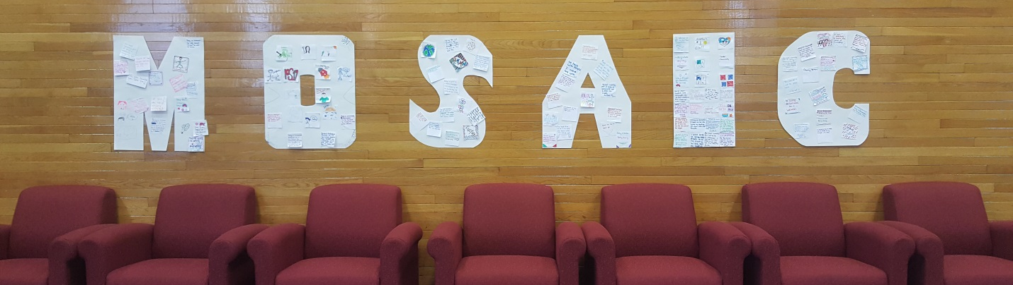
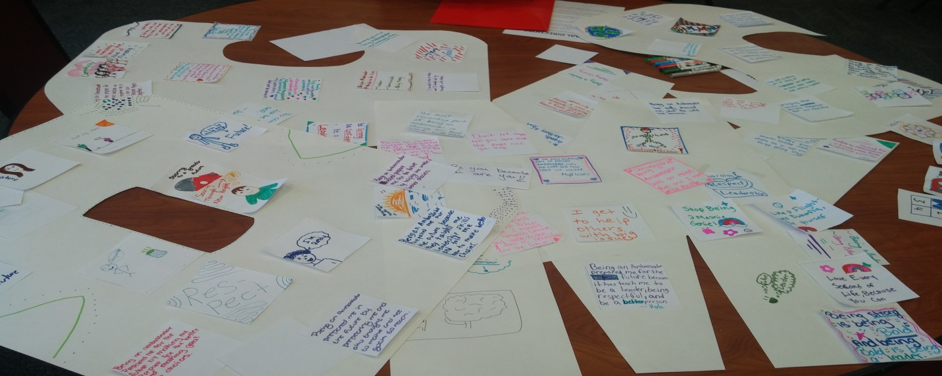
LETTERS MURAL (above)
MOSAIC MURAL (left)

Welcome Speech Considerations

No matter the structure of your Showcase, it will be important to begin the event with a welcoming speech. Two to three guest speakers should give less than 5-minute speeches to welcome the students to the Showcase. Themes of the speeches in the past have included: overcoming obstacles, valuing diversity, and serving others. The leaders giving these speeches can come from inside or outside of the school community, and can be youth or adults, however, it is important that they represent diverse backgrounds so that students can see themselves in these leaders.
Ground Rules: The Welcome Speeches should also include a basic conversation about ground rules for the day and an outline of the agenda for the Showcase.
Relaxation/Mindfulness: Before students present their projects, a brief mindfulness or relaxation activity can be helpful to model emotion regulation skills. This element can be removed if time does not allow for it. Two example mindfulness scripts can be found below.
Additional Ideas: The Welcome Speeches could also include a video of other groups of students engaging in service projects.

Mindfulness Activity Scripts

- ACTIVITY #1
  - Before we move on, we are going to do a little activity to relax our brains, calm us down, and get ready to hear about everyone's amazing projects.
  - First, I want you to get into a comfortable position in your seats, sitting upright, and closing or lowering your eyes. Excellent.
  - Now, place all your attention on the sound you are about to hear. Listen until the sound is completely gone. Please raise your hand when you can no longer hear the sound.
  - [Ring Chime]
  - [When most or all have raised their hands] Now, gently lower your hands and remain silent as you use your mindful listening skills to notice other sounds you hear in the room for the next 30 seconds.
  - Okay, now that we have done a little listening exercise, did anyone notice sounds they hadn't heard before? Does anyone feel calmer or more relaxed?
  - Great! When you take a moment to focus your mind on the here and how, it can help you feel calmer and more prepared for performances or presentations. Thank you all for participating. From now on, when you hear this chime [ring chime] it will signal a transition to a new activity. Let's continue our mindful listening as we move into presentations [ring chime].

- ACTIVITY #2
  - Before we move on, we are going to do a little activity to relax our brains, calm us down, and get ready to hear about everyone’s amazing projects.
  - First, I want you to take a moment to think of your favorite food. Once you have it in your mind, you can put your finger on your nose to show me you’ve thought of it.
  - Now, can I have everyone close their eyes? Good.
  - I want you all to try to think of the way that your favorite food smells.
  - Once you have it in your head. Imagine you are breathing in that scent right now. Go ahead and breathe in through your nose. Now out through your mouth.
  - Try again: in through your nose and out through your mouth. And again: in through your nose and out through your mouth. Keep going and keep trying to picture your favorite scent and as you do try to relax and enjoy it, as if you were really smelling it now. (continue this for maybe half a minute)
  - Okay now that we have done a little breathing exercise does anyone feel calm? Relaxed? Happy?
  - Great! When you take a moment to breath, it can really help you to refocus and relax, especially if you are feeling bored or nervous. Thank you all for participating and doing a little breathing with me. Now let’s move into presentations.

Project Presentation Considerations

An essential component of any Showcase is the student presentations of their projects. The presentation time should not be longer than one hour, and thus the length of each project presentation can be adjusted based on how many projects there are. The goal of the presentation is to give groups presentation experience and to get the audience excited to ask follow up questions and in general want to learn more. The length of the presentations will depend on how many groups are attending the Showcase. It is important to keep this portion of the program running quickly so that students do not become bored!
If there are too many groups for the time period available, a presentation for each group would not be possible. In this situation, alternative opportunities for groups to be represented and acknowledged publicly should be used, such as a video montage with 30 second descriptors of each group’s project, or a program with a blurb written by each group about their project distributed to all Showcase attendees.
See Sample Showcase Project Presentation Script for a sample of what the students can say to introduce their project. These scripts should be rehearsed ahead of time.

Sample Showcase Project Presentation Script
Please use this sheet as a guide when presenting your projects!
Introduction
We are the Ambassadors from: SCHOOL/CLASS
One thing about our team that most people don’t know is:
_____________

Problem Description
In our school, we wanted to address: BULLYING, CULTURAL DIVERSITY, ETC.
Project Description/Plan
In order to do this, we thought it would be a good idea to plan a MULTICULTURAL EVENT/ANTI-BULLYING PROJECT, ETC.
ANSWER:
Where and when did the project take place?
Who participated in OR saw the project?
What was the project about?

Noticing Success
Name one way your project was successful: __________

Learn More
To learn more about our project, please _________ (VISIT OUR BOOTH/SEE OUR VIDEO/VISIT OUR CLASS, ETC.)

Food Considerations

Depending on the length of your Showcase, it may be necessary to serve a meal or snack. This could be provided by the host of the showcase (a school, university, or community institution), catered, or could be a potluck (for example, if your Showcase is set up as an evening event with parents as guests). During the meal or snack, informal conversations or more structured ice breakers can be set up at the students’ tables. It is important for students to have the opportunity to mingle with the adults who are attending the Showcase so that they can have a chance to talk more about their experiences over the school year and discuss future plans and goals, especially around college and careers. Appropriate budget arrangements must be made, as well.

A College or Community Panel Q & A can also occur during the meal/snack.

Award Considerations

It is important that the Showcase conclude with a formal recognition of the hard work from the year. Depending on the size and scope of the Showcase and budget resources, either individual Ambassadors or entire Ambassador teams should be awarded a certificate that celebrates a specific accomplishment from the 8th Grade PPP or 6th and 7th Grade STAT project.
Sometimes sponsors can help to provide resources. In one school district, sponsors supported a logo contest for a t-shirt design and then t-shirts were made and distributed to all student leaders who participated.
As you will see below, “awards” are meant to provide recognition for accomplishment and growth. Hence, “awards” should not be competitive, but rather, fully inclusive. Figuring out these awards is usually a fun and creative process.
See sample certificates and sample award scripts below.

SAMPLE CERTIFICATE

Sample Award Scripts
“We have the award for a group of ambassadors who used their compassion to communicate their message of anti-bullying to their school. By creating an impressive skit with a meaningful message, a peer mentoring program and perhaps most of all, through their influential assembly, these ambassadors impressed us all. Because of this, the award for The Caring Community Creators goes to Local School A!"

“Next, we have an award for a group of ambassadors who were able to use their empathy and compassion to cross borders and bring unity. They did this through representing several countries at their Multicultural Event! Because of this, the award for The Compassionate Culture Connectors goes to Local School B!”

“And next we have an award for the Ambassador Team who showed helpful generosity and empathy to think about creating a cleaner school and community. This team made posters, created a video, planted flowers, and prepared their student body to think hard about the effects that littering can have on the world we all live in. We know this team is going to go on to do great things and make our world a better place. The Better School Creators award goes to Local School C!”

Closing and Dismissal Considerations

To wrap up the ceremony, a closing activity can be used to help solidify the message of the event: that students’ voices matter to improving their school and community.
One way to do this is to use a pledge. In past 8th Grade PPP Showcases, Ambassadors recited the “Ambassador Pledge.” If you are planning a Showcase that includes students who are not Ambassadors, the pledge can be adapted to apply to all students. See the example Ambassador Pledge below.
Be sure to plan a dismissal/departure process that is clear. For a full day program, make sure this includes leaving enough time for students to get materials from project booths or any materials left in the meeting space while they do tours, etc. For an evening program, sometimes it is valuable to have optional programming at the end, so that parents with young children or travel concerns can leave early without missing key parts of the program. This would involve setting and announcing an ending time.

Sample MOSAIC Ambassador Pledge

As a MOSAIC Ambassador, I pledge
To address issues facing my peers and my community,
To show resilience when overcoming obstacles,
To always lend a hand to someone in need,
To plan for a positive future for myself and my peers,
And to use all my skills and good character for a positive purpose!

Project Fair (Optional) Considerations

A Project Fair is a great component for a Showcase that is longer (at least ½ a day), includes many (at least 5) student projects, and held in a large space. During the Project Fair, students can be broken into groups: Presenters, staying at their own booth and speaking to visitors, and Listeners, traveling around to visit other student booths and learn about their projects. The students rotate through these groups so that they have a chance to be in each group. Approximately 15 minutes should be spent in each group. To encourage students to visit every booth as a “Listener,” a passport can be used to track how many groups the student visited. A small prize can be given for collecting stamps from every booth. (NOTE: The logistics of this depend on the size of project fair. It may not be realistic to visit every group, so students could aim to get a certain percentage of the passport filled, or aim to get one row completed).
Listeners can also be encouraged to provide positive feedback. Jars and sticky notes can be placed at each booth to encourage students to leave notes for each other on positive things they saw in the presentation at the booth. Groups can select a time to go through these comments after the Showcase.

Materials needed:
- Booths (tables, extension cords)
- Presentation materials (posters, computer, other materials provided by groups)
- “Passports” (in student folders)
- Stamps (for passports)
- Instructions for “Leave a Note”
- Jars
- Sticky notes
See sample instructions and photos below.

Sample Project Fair Instructions

- I want to explain the different activities that will be happening during the Project Fair. There are three activities and each of you will get a chance to do each one.
  - First, there are the Presenters. When you are a presenter, you will be in charge of standing by your project and presenting your project to people as other students come up to you.
  - Second, there are the Listeners. As the listeners, it is your job to visit all of the projects and learn more about other Positive Purpose Projects. At each project, you should listen to what the students did, ask questions, leave a positive note for the team about their project, and make sure to get your Passport stamped by the chaperone at each booth.
  - Third, there are the Artists. As artist, you will get a chance to work more on the mural that your team started this morning.
- Now that you know the activities you will be working on, I would like everyone to look at the “Passport” that is at their seat. If you have a [ORANGE] passport, raise it up nice and high. Now, if you have a [YELLOW] passport, wave it around. Thank you, and finally, if you have a [PURPLE] passport, raise it up. As you can see there are three colors and there are three different activities to do during the fair, so the color passport you have is going to designate where you are starting. Pop quiz. What are you going to do with this passport?
- Please make sure to take your Passport with you as you travel around. At each booth and at the mural station, you will be able to get your passport stamped. You are also encouraged to leave a positive note about their project in the jar at their table. After you get all 9 stamps, then you get a special prize. You can go to the XXX table to get your prize.

Team 1 | Team 2 | Team 3
Team 4 |  | Team 5
Team 6 | Team 7 | Mural Activity

Sample Project Fair Passport

Student Project Fair Booths
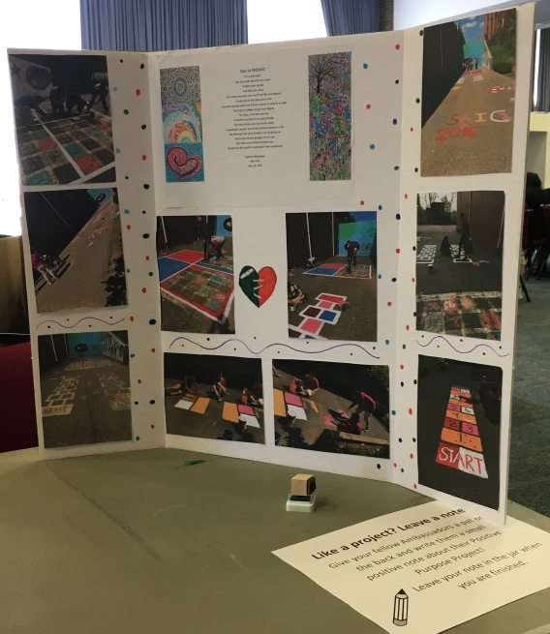
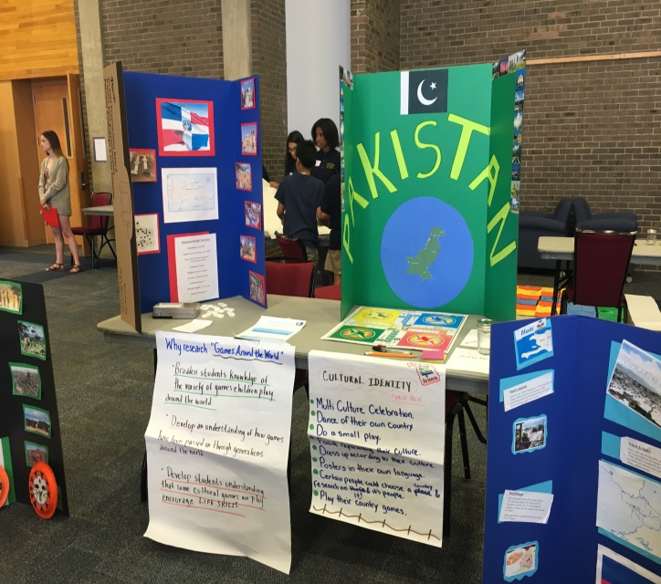
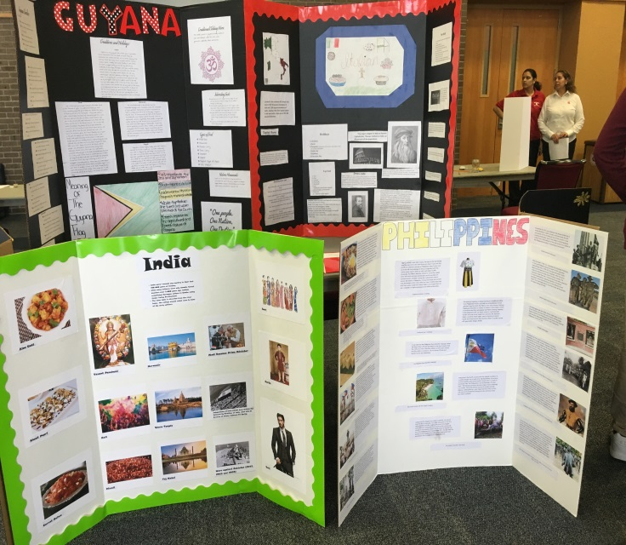
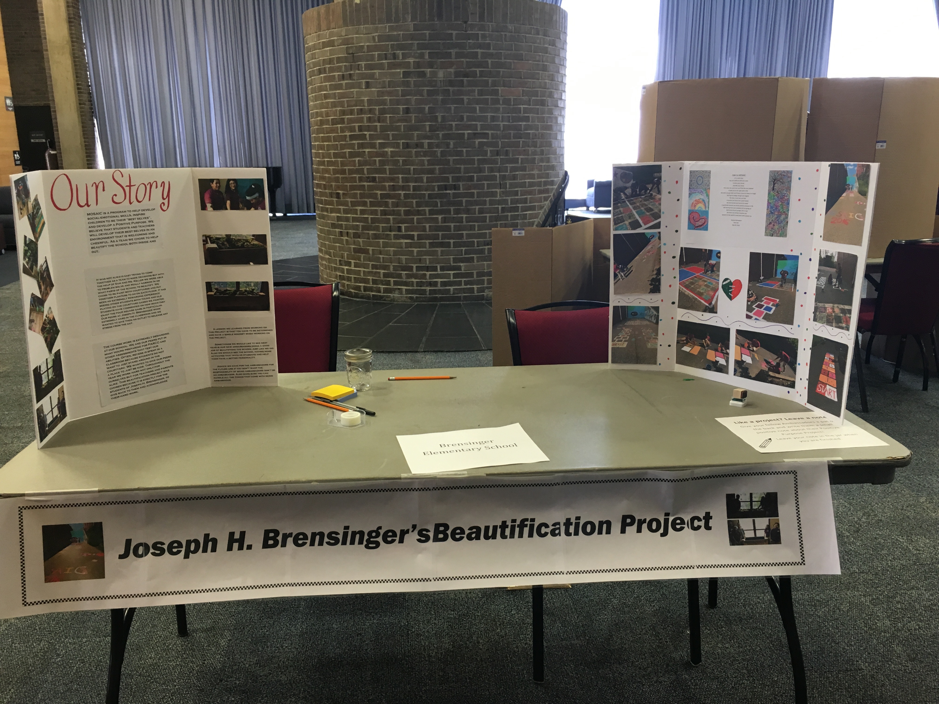

Note Instructions
Like a project? Leave a note!
Give your fellow Ambassadors a pat on the back and write them a small positive note about their Positive Purpose Project!
Leave your note in the jar when you are finished.

Guest Speaker/Q & A Panel (Optional) Considerations

A panel about college admissions and/or careers is a valuable way to help students connect their leadership and service experiences to their future educational and career goals. The panel works especially well when it includes current undergraduate students from diverse backgrounds close to those of the students, who can speak to the college admissions process, or to those relatively new in their careers who can speak to the path they took to get there (which helps students understand the value of staying in school and doing well, and playing leadership roles). Panelists should each give a 1-2 minute introduction and the rest of the panel can be opened up to questions from the audience about the college admissions/career development process.
Alternatively, or in addition, speakers representing community sponsors- first responder groups, religious and civic organizations, parent groups, business, local government, alumni groups, as well as leaders in your educational setting, also can give brief, inspiring, appreciative messages and/or form a Q and A panel for students.

Additional (Optional) Activity Ideas

Tour: If the Showcase takes place on a college campus, a college student-led tour is an excellent activity to help students to see themselves as college students in the future.
Video/Music Performance: In addition to featuring guest speakers, the Showcase can include guest performers, including musicians or singing groups, including student groups. This activity can be especially fun if it includes a sing-along chorus or an inspiring message.

Case Example: Full-Day 8th Grade PPP Showcase with Multiple Schools held at a Public University

Below, you will find materials from a previous successful 8th Grade PPP showcase. This Showcase was held at Rutgers University, and had Ambassador teams from six Jersey City Middle Schools. This case example is intended to provide a clear vision of what one kind of full-day Showcase can look like, not to prescribe the way your Showcase needs to look! In this case example, you will find: a detailed agenda, script, materials checklist, and PowerPoint slides.

Case Example Full-Day 8th Grade PPP Showcase Detailed Script

ROLES:
- MC: Individual to lead the stage presentation elements of the showcase
- Speakers: At least three speakers (SECD or MOSAIC rep, School District rep, University rep)
- Q & A Panel: 2-3 college students and a moderator
- Timekeeper: Individual who tracks time, keeps speeches on track, notifies when transitions to next activity must occur
- Photographer: Takes photos throughout event and especially during award ceremony, takes a photo of each group
- Additional support:
  - Mic runners: Necessary for Q & A panel if a large room
  - Additional: Additional presenters can lead mindfulness activity, pledge, as needed
  - Greeters and escorts: Individuals to be stationed at each area of the Showcase where ambassadors could need guidance (see agenda below for station examples)
  - Sign in table/greeter: Individuals to greet teams and to give folders to chaperones and provide initial instructions
9:00am Arrival and Opening Activities
- MOSAIC Staff Station 1 (Greeters)
  - Ambassadors enter and are greeted by MOSAIC staff.
- MOSAIC Staff Station 2 (Escorts)
  - Ambassadors are led to the sign-in table by MOSAIC staff.
  - Ambassadors stop at the table to sign in and fill out a nametag and pick up a folder.
  - Chaperones pick up a packet with schedule for the day & other relevant info at the welcome table.
- MOSAIC Staff Station 3 (Escorts)
  - Ambassadors are directed into Project Fair room and to the banquet room where they can put down their belongings.
- MOSAIC Staff Station 4 (Escorts)
  - Ambassadors are then directed to the Project Fair room where they will set up their booths and take part in opening activities.

9:10am Project Fair Booth Set Up and Opening Activities

- Activity 1 – Project Fair Booth Set Up (Station 5)
  - First each Ambassador team finds their project booth (denoted with their school name on it) and sets up their presentation area.
  - People from the MOSAIC team will be floating to help teams get their booths ready.
- Activity 2 – MOSAIC Ambassador Mural (Station 6)
  - Once Ambassadors have set up their booth, they will be directed to the Mural Activity. A few members of the MOSAIC team will be on hand at this station to tell Ambassadors what they will be doing and help teams as needed.
  - Mural Backdrop:
    - Each school will receive a post it note on which they will answer a prompt to stick on to the mural. This will be 1 of 2 post-it notes that each student will receive
  - Mural Media:
    - Ambassadors use markers to work on their post it notes (this eliminates messier media like glue, paint, and generally anything wet – we can laminate these posters after they are done so they last if they end up hanging in central office)
  - Mural Content:
    - Each student gets 2 post it notes as tiles to fit in a mural of the world. Groups will receive one prompt for each post it:
      - “I want to be….” (Blue post-its)
      - “What I learned as an ambassador it….” (Green Post-its)
  - This mural may be hung in central office or their school (with approval from school/district administrators)

9:15am Transition to the Banquet Room
Transition to Welcome Speeches (5 minutes):
- Give a warning announcement about 5 minutes before welcome speeches are set to begin.
- When transitioning to welcome speeches, announce that everyone should move back to their seats in the banquet room.

9:20 am Stage - Welcome Speeches
- (NOTE: PowerPoint should have nice background with something generic about the day and event- see sample slides below)
- Speech 1: From someone inside or outside the school in an SECD or MOSAIC leadership role (~5 minutes)
  - Welcome
- Speech 2: Leader in the school district (~5 minutes)
  - Pride in the Ambassadors as leaders
  - Expectation that they will bring this to any school they are in next year
- Speech 3: From university (admissions, student engagement, etc.) (~5 minutes)

9:35 am Ground Rules & Agenda
- MC for the day introduces self and go over ground rules & agenda (Can use PowerPoint for visual—see sample below)
- Advance PowerPoint slide to show agenda and ground rules
- Be sure to address bathroom and waste basket protocols
9:37 am Mindfulness Activity (Select one)
- ACTIVITY #1
  - Before we move on, we are going to do a little activity to relax our brains, calm us down, and get ready to hear about everyone's amazing projects.
  - First, I want you to get into a comfortable position in your seats, sitting upright, and closing or lowering your eyes. Excellent.
  - Now, place all your attention on the sound you are about to hear. Listen until the sound is completely gone. Please raise your hand when you can no longer hear the sound.
  - [Ring Chime]
  - [When most or all have raised their hands] Now, gently lower your hands and remain silent as you use your mindful listening skills to notice other sounds you hear in the room for the next 30 seconds.
  - Okay, now that we have done a little listening exercise, did anyone notice sounds they hadn't heard before? Does anyone feel calmer or more relaxed?
  - Great! When you take a moment to focus your mind on the here and how, it can help you feel calmer and more prepared for performances or presentations. Thank you all for participating. From now on, when you hear this chime [ring chime] it will signal a transition to a new activity. Let's continue our mindful listening as we move into presentations [ring chime].

- ACTIVITY #2
  - Before we move on, we are going to do a little activity to relax our brains, calm us down, and get ready to hear about everyone’s amazing projects.
  - First, I want you to take a moment to think of your favorite food. Once you have it in your mind, you can put your finger on your nose to show me you’ve thought of it.
  - Now, can I have everyone close their eyes? Good.
  - I want you all to try to think of the way that your favorite food smells.
  - Once you have it in your head. Imagine you are breathing in that scent right now. Go ahead and breathe in through your nose. Now out through your mouth.
  - Try again: in through your nose and out through your mouth. And again: in through your nose and out through your mouth. Keep going and keep trying to picture your favorite scent and as you do try to relax and enjoy it, as if you were really smelling it now. (continue this for maybe half a minute)
  - Okay now that we have done a little breathing exercise does anyone feel calm? Relaxed? Happy?
  - Great! When you take a moment to breath, it can really help you to refocus and relax, especially if you are feeling bored or nervous. Thank you all for participating and doing a little breathing with me. Now let’s move into presentations.

9:40 am Ambassador Project Presentations on Stage
- Each Ambassador team has 3 minutes to introduce their project before the project fair. This can be through a small speech or video.
- Ambassador Teams will be called up to the stage one team at a time:

MC Script:
- Good Morning Ambassadors! I am so excited to see all of you here! My name is _____ and I work here at Rutgers on the MOSAIC project. Here at Rutgers, we have been hearing amazing things about your projects. We can’t wait for you to share them with us.
- Now, I am going to ask teams to come up to the stage one at a time to introduce your projects. When your team is called, your representatives should make their way to the stage.
- I am also going to ask that the NEXT team to present come up and wait “On Deck”.
- After the presentations, you will all go to your booths and you will get to learn more about the projects there.
- Order:
  - First up we have School 1, on deck School 2
  - School 2, on deck School 3
  - School 3, on deck School 4
  - School 4, on deck School 5
  - School 5, on deck School 6
  - School 6, on deck School 7

10:20 am Transition to Project Fair
- Let’s have a big round of applause for all those presentations.
- Thank you all for sharing a little about your project with us. I look forward to hearing more about everyone’s projects during the Project Fair.
- It is time now to start heading to the Project Fair, but before we move into the room with your booths, I want to explain the different activities that will be happening during the Project Fair. There are three activities and each of you will get a chance to do each one.
  - First, there are the Presenters. When you are a presenter, you will be in charge of standing by your booth and presenting your project to people as they come up to you. Make sure to use your BEST speaking skills while being a presenter.
  - Second, there are the Listeners. As the listeners, it is your job to visit all of the booths and learn more about other Positive Purpose Projects. At each booth, you should listen to what the students did, ask questions, leave a positive note for the team about their project, and make sure to get your Ambassador Passport stamped by the chaperone at each booth.
  - Third, there are the Artists. As artist, you will get a chance to work on the mural
- Now that you know the activities you will be working on, I would like everyone to look at the “Passport” that is at their seat. If you have a [ORANGE] passport, raise it up nice and high. Now, if you have a [YELLOW] passport, wave it around. Thank you, and finally, if you have a [PURPLE] passport, raise it up. As you can see there are three colors and there are three different activities to do during the fair, so the color passport you have is going to designate where you are starting. Pop quiz. What are you going to do with this passport?
- Please make sure to take your Passport with you as you travel around. At each booth and at the mural station, you will be able to get your passport stamped. After you get all 9 stamps, then you get a special Rutgers prize. You can go to the XXX table to get your Rutgers prize.
- Now when, I call your color, please quickly and quietly go to your places for your first activity. In about 15 minutes you will switch to a different activity, so you’ll have to listen up for directions.
- If you have [ORANGE], you are going to be our first presenters. That means you are going to stand at your team’s booth and present your project as people come around. If you have [BLUE], you are going to be the first listeners, and it is your job to walk around to each booth and learn about the different projects. If you have [PINK], you are going to be our first artists. You will continue working on your team’s mural at [the mural tables].
10:25 am Project Fair
- Ambassadors are doing one of three things during this time:
  - One – Presenting Ambassadors
    - These Ambassadors are responsible for standing by their booths and introducing their project to people who walk by
  - Two – Listening Ambassadors
    - These Ambassadors are rotating around to visit every team’s booth.
    - They stop at each booth, listen to the presenters talk about their project and leave a positive comment/note about the booth. These notes are not mandatory (as this would likely take too much time), but highly recommended.
    - Before they leave each booth, Ambassadors get a stamp on their “Passport” from the chaperone in charge of stamping at each booth.
  - Three – Mural Ambassadors
    - During this time, Ambassadors will be able to continue working on their Murals in smaller groups (Mural began during Opening Activities)
- OPTIONAL: During this time Ambassadors are also interviewed by film crew (this is for video of event).
- Note: There needs to be a way to make sure Ambassadors know when to switch from “Listener” to “Presenter” to “Mural.” Ideas include using a chime to quiet the room and announce the change. Or play a certain song over speakers (would need to explain ahead of time.)

11:10 am 5-minute warning
- Give Ambassadors a 5-minute warning to wrap up the Project Fair
11:15am Transition to lunch
- Dismiss students to lunch one group at a time. (Can either dismiss to sit at tables or dismiss straight to lunch line).
11:20am Call up tables for lunch/transition to Panel
- Welcome back, Ambassadors! Give me a show of hands. How many people thought that it was easier than you expected to present your booths? How many people thought it was scarier?
- I was so impressed by your hard work and professionalism.
- You’ve worked so hard! Now, it’s time to relax and be rewarded for your work! We are going to do lunch first. Then we will have our Rutgers panel. At the very end we have some awards to give out.
- Call up teams by opposite order they presented in to the lunch line.
11:40am Musical Performance
- We now have a performance for you ambassadors by undergraduate and graduate students and members of the SECD Lab and Collaborative Center here at Rutgers! Please feel free to join in as song lyrics will be on screen for you and in your folder!
- Singing – “We are the World”
- Thank you all! We will now transition into the Panel to answer some of your questions about Rutgers and your potential journey to Rutgers!
11:45am Q & A Panel
- Depending on room logistics, you may want people assigned to hold the mics and take them to students who have questions.
12:10pm Transition Activity (Optional)
- This activity has typically been dropped due to time constraints, but it is nice to have an activity if needed to fill time.
- Now that we have spent some time talking about Rutgers and the college experience, let’s take some time to think about the future. At your table, I would like you to take turns sharing your answers to the following questions.
- First, share your dream college. If you don’t know exactly what college you would want to attend, share the qualities you would like in a school
- Now, share your dream career. If you don’t know exactly what this is, share the qualities you would like your future career to have.
- Finally, share your dream life in 20 years. What will you be doing? Where will you be living? What will bring you happiness?
12:15pm Announce Awards
- And now, it is time to recognize all of you for your hard work this year. We are going to be announcing awards for each Ambassador Team. We also have certificates for every Ambassador that we will give to your school’s liaison.
- As we call up each school, please come up on stage to get your award and take a picture with [SCHOOL OR COMMUNITY LEADERS] on the stage. [NOTE: It is nice to have an official hand shaker, a representative from the district to give the awards]
- Just like you’ve been doing all day, please be respectful of each team while they are getting their award.
- Our day is almost done!
- Award scripts:
  - The first award of the afternoon goes to a group of ambassadors who were passionate about their community and believed in active participation in making it better. By celebrating different cultures and skills, this group worked together to create a welcoming culture in their school by bridging the gap between their outside community and school community. Because of this, The Community Service Advocates Award goes to the team from School 1!
  - Next we have the award for a group of ambassadors who used their compassion to communicate their message of anti-bullying to their school. By creating an impressive skit with a meaningful message, a peer mentoring program and perhaps most of all, through their influential assembly, these ambassadors impressed us all. Because of this, the award for The Caring Community Creators goes to School 2!
  - Another team that worked hard to overcome obstacles showed their constructive creativity by taking initiative and working with teachers and administration at their school to have a cleanup and beautification competition! They rallied the whole school in the Classroom Clean-Up and were able to give a pizza party to the winning classes! Because of this great success, The Flawless Visionary Award goes out to School 3.
  - Next, we have an award for a group of ambassadors who were able to use their empathy and compassion to cross borders and bring unity. They did this through representing several countries at their Multicultural Event! Because of this, the award for The Compassionate Culture Connectors goes to the team from School 4!
  - And next we have an award for the Ambassador Team who showed helpful generosity and empathy to think about creating a cleaner school and community. This team made posters, created a video, planted flowers, and prepared their student body to think hard about the effects that littering can have on world we all live in. We know this team is going to go on to do great things and make our world a better place. The Better School Creators award goes to the team from School 5
  - Next, we have an award recognizing a team who really used constructive creativity and compassion to think outside the box to be champions for their Positive Purpose Project. This team rallied their school and worked hard to get other students involved in their anti-bullying initiative and school beautification project. This is a group of leaders knows how to use their communication skills to get people to pay attention to their Project. This award is The Future-Minded Compassionate Creators, which goes to the team from School 6.
  - Giving another person your attention is one of the greatest gifts you can give and these Ambassadors did just that. The Ambassadors from this school creatively designed and led a conference that motivated their fellow students to improve their listening. With improved listening skills, students at this school will be better prepared to focus in their classes, understand their friends and family, and excel in their careers. Congratulations to these Ambassadors for giving people their attention and the gift of listening! This award is The Generous Listeners Award and it goes to the team from School 7!

- Mr. Walker Award:
  - We would now also like to give a special thank you to the Assistant School Superintendent for facilitating this trip and the MOSAIC program for the Jersey City Public Schools. His dedication to this program has allowed it to flourish as it has so far in Jersey City. For this, the University would like to present an official commendation from the Chancellor to the Assistant School Superintendent for his career of dedication to children.
12:45pm Lead Pledge & Closing Remarks
- This has been a wonderful and inspiring experience to see all that you have accomplished this year. We are going to close with a reading of the Ambassador Pledge so that we can remember the positive purpose we shared on this day and continue being ambassadors in our schools and communities.
- Ambassador Pledge:
  - “As a MOSAIC Ambassador, I pledge
  - To address issues facing my peers and my community
  - To show resilience when overcoming obstacles
  - To always lend a hand to someone in need
  - To plan for a positive future for myself and my peers
  - And to use all my skills and good character for a positive purpose!”
- Closing Remarks:
  - Thank you all for attending the second annual MOSAIC Ambassador Showcase. You have all worked so hard this year, and the results have been very impressive. Remember to take what you learned this year and use your MOSAIC skills and virtues as you continue to work towards your positive purpose!

12:50pm Transition to Tour
- We would now like to direct you into groups for a tour of Rutgers’ College Avenue campus. I will call out each school and then point you to your tour guide for this afternoon. They will meet you at the exit door (by the stage) and will lead you out.
- Please remember to take all your personal belongings with you. The Rutgers’ Assistant have already packed up your booth items for you which will be on the bus for you when you get back.
1:00pm Rutgers Tour
1:45pm Announce Dismissal to Buses

Sample Showcase Materials Checklist

Sign-in table
- Name tags
- Pens/Pencils
- Ambassador Folders:
  - Bios for Panel Members
  - Agenda for Ambassadors
  - Ambassador Pledge
  - Project Fair Passport
- Chaperone Folders
  - Folders
  - Chaperone Agenda
  - Attendance Sheet
  - Awards/Certificates for individual Ambassadors

Materials for Event Staff
- Agenda for Event Staff (More detailed)
- Script Document for MC
- Time cards (For timekeeper for speeches)

Project Fair Room Materials
- Each Booth:
  - Flyers w/ each school name (1 copy)
  - Directions for leaving a note
  - Mason jar
  - Post-it notes
  - Stamps
  - Extension cord/access to outlet
  - Table
- Table with prizes for completing Project Fair Passport
- Mural activity space
  - Mural materials
  - Post its or tiles
  - Mural instructions (10-15 copies printed)

Banquet Room/Stage room
- Centerpieces with school name/team name for each table
- Set up for panel (tables/chairs)
- Any materials needed for additional performance or activity (mindfulness bell, guitar, microphones)
- One computer with PowerPoint and all videos for presenting teams (on stage)
- Certificates/Awards for teams (Certificate and physical award for each team- school name or team name listed on award)
- Lunch

Sample PowerPoint Slides:
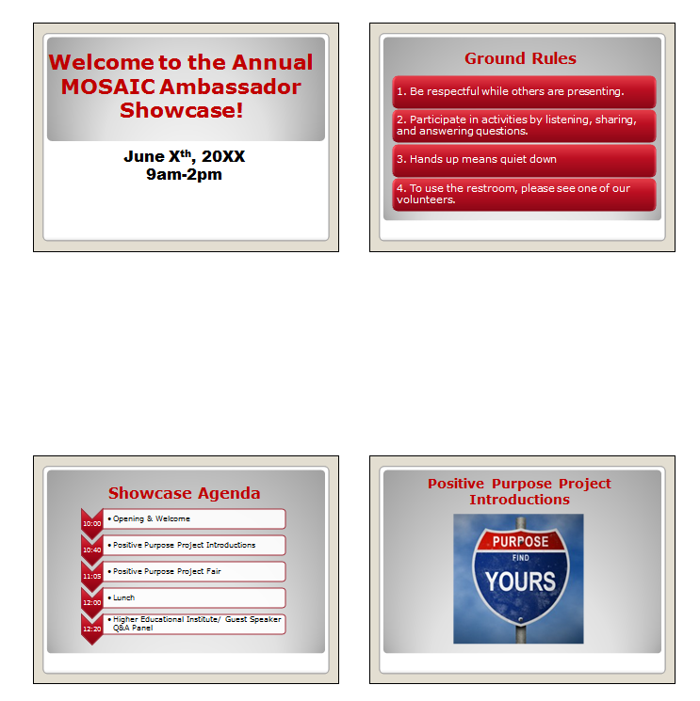

Concluding Thoughts

We hope that this guide has been helpful to you while planning your Showcase. For additional resources, please refer to the Rutgers SECD Lab website (www.secdlab.org), and for additional support, please email the Rutgers SECD Lab at secdlab@gmail.com.

