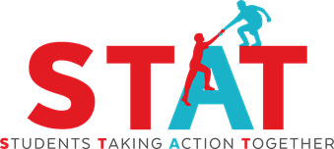

Students Taking Action Together (STAT)
Yes-No-Maybe Current Event Discussion Guidelines

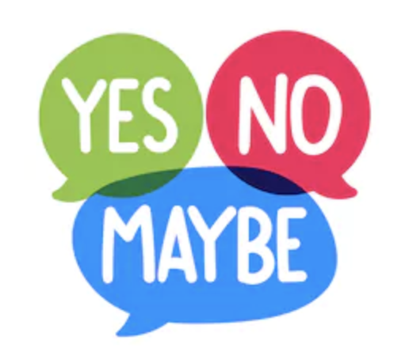

Objective:

Allow students the opportunity to answer “yes”, “no” or “maybe”, then explain their stance in response to a statement about a current event. This will enable students to further develop the fundamental habits for respectful listening, engaged dialogue, and peer opinion sharing, which are the foundations of democratic action.

For the teacher, this activity is an opportunity to engage students experientially in how their peers can have similar and different opinions from themselves on various matters, and how inquiry is better than assumption when it comes to understanding the perspective of others.

Standards alignment:
- See STAT Standards Alignment Document
- Apply local standards relevant to your topic and grade level

Materials:

- Signs that indicate “Yes”, “No”, and “Maybe” corners of the room
- Pens
- Pencils
- Notebook or notebook paper

Instructions: (Note: Italicized words can be read directly.)

- Introduce Yes-No-Maybe (2-3 min)
  - “Today, we are going to start learning some skills that you will need, now and as you get older, to be effective and involved citizens of your classrooms, your school, your community, and the wider world. It involves thinking about our own opinion on issues and considering others’ opinions as well.”

  - Designate 3 separate spaces/areas in the room, one for “Yes”, “No”, and “Maybe”

  - Tell students: “I am going to read a sentence and when I am done, you will move to the Yes, No, or Maybe spot of the room depending on if you agree or not (Yes=agree, No=disagree, Maybe=not sure). If you agree and move to ‘Yes’, you have to share one reason why you agree. If you move to ‘No’, you have to say why you do not agree. If you pick ‘Maybe,’ you have to share both something you agree with and something you disagree with about the statement.”

- Carry out Yes-No-Maybe (8-10 min)

  - Generate and read statements that do not have a clear right or wrong answer. Ethical and values-based questions that are related to your course content often lead to fruitful discussions but you may want to practice with more neutral statements first. After you read the statement, ask students to move to the appropriate part of the room (or in other ways form a group of those saying Yes, No, or Maybe).
  - For practice purposes, you may want to begin with some general statements not connected with specific content you are teaching. Some examples include:

    - Students in school should always stand for the pledge of allegiance.
    - The Constitution states that no person shall be “deprived of life, liberty or property without the process of law”. Is this present in today’s society?

The statement “We hold these truths to be self-evident: That all men are created equal; that they are endowed by their Creator with certain unalienable rights; that among these are life, liberty, and the pursuit of happiness” within the Declaration of Independence, is still necessary to guard the rights of all who inhabit the United States.

Since Deferred Action for Childhood Arrivals (DACA) was put into place by executive action without congressional approval it is unconstitutional and should not continue to be upheld in the United States.

Citizens should help when they see someone in trouble or need of assistance.

- Student Discussions

- If you are in the agree group, join with three or four other students and share one reason why you agree. If you said ‘No,’ share one reason why you disagree and how you would make the situation better. If you picked ‘Maybe,’ share both something you agree with and something you disagree with about the statement.”
- After you share within your group, pick one or two students to summarize your group’s ideas and share them when I call on you.
- Repeat for other statements as time/curriculum goals allow.

- Reflect on Similarities and Differences (2-6 min)

  - Remember that the point of Yes-No-Maybe is to encourage peer opinion sharing and respectful listening. You are not being asked to create a consensus or resolution or find the “best” or “right” answer.
  - After each statement you complete, as time allows, review the responses of the groups, giving them a chance to add/correct your summary if they wish. This helps ensure that everyone’s views were heard and reflected adequately in the summaries.
    - Ask students, “Was there anything that surprised you during the activity?”
    - Point out that, “You had many different thoughts and there was not a single right answer.”

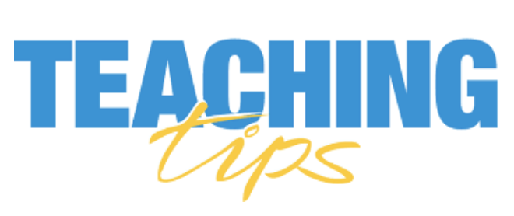

- Collaborate with a mental health professional in your school:
Activities such as Yes-No-Maybe or any similar open-ended exchanges of opinions could elicit some strong feelings from some students. This is good and correlates with deep learning, but also can bring about some discomfort. If you have any hesitation, speak to a school mental health professional either in advance or as a debrief, or ask that person to attend, co-lead, or even model an activity for you to help you feel more comfortable.

- Ongoing lesson format: The lesson guidelines above are written in the context of the initial introduction of Yes-No-Maybe to students. Once the class has experienced this, you will be able to move quickly into the activity by saying that you are going to do a Yes-No-Maybe activity.

- Addressing peer conflict: What happens if there’s a conflict in discussion? Tools we can use:

  - Acknowledge emotions, review class norms, and problem-solve

    - Acknowledge the feeling in the room.
    - Take a break and have students quickly write down or draw what they may be currently feeling, thinking, and or experiencing.
    - Reorient students to the class norms and skills you have discussed regarding showing respect, empathy, and/or responsible listening to others. Help students use the tools to communicate their experiences in a way that encourages understanding.

- Tweaking materials: Can I create variations in this activity?

  - By all means, yes! Just document them for us. Some examples we have seen are:

    - To have students write their ideas before stating each side of the Yes-No-Maybe
    - Revisiting their position in writing after each or all sides of the Yes-No-Maybe
    - Keeping a Yes-No-Maybe notebook, journal, or electronic folder where students keep track of how their ideas have changed as a function of having discussions with their peers during the activity
    - Yes-No-Maybe can be given before a new lesson is started in order to get students involved in the lesson; additionally, another Yes-No-Maybe can be held in the middle of or end of the lesson to check-in with students on if/how their opinions changed.

- Generating Yes-No-Maybe topics and questions: What are some tips for generating fruitful Yes-No-Maybe topics, questions, and discussions?

  - Selecting relevant topics: We suggest choosing Yes-No-Maybe topics that are based on historical content and questions you are teaching or current events that relate to what you are teaching and for which there might not be a clear answer or solution.

  - Creating unbiased questions: As adults, we have our own opinions about many issues. The point of the Yes-No-Maybe is not for the students to arrive at a particular position but to learn how to reason, listen, weigh options, etc. So, it’s important to frame the questions in a neutral and unbiased way.

  - For instance, a Yes-No-Maybe prompt that says, “The Good Samaritan law should be put in place within all 50 states” can be made more neutral by saying, “Citizens should be proactive when they see someone in trouble or need of assistance (e.g., Junior from Bronx, NY)”. The former prompt assumes without question that one’s duty to act be determined by law rather than the will of the individual—which has a restrictive connotation and does not allow one to first think about citizens getting involved; rather demands one to be involved. The former question does not require a person to act-rather it leaves the decision solely up to the individual. This latter question creates an opportunity for students to formulate their stance on the topic in the Yes-No-Maybe activity.

