VIRTUES & SKILLS
Responsible Diligence & Emotion Regulation
Supplemental Activity
Self-Management

OBJECTIVE  Students will be introduced to the idea of self-management to stay focused and productive. | MATERIALS  - MOSAIC journal/notebook  - Pens/Pencils
TEACHER TIPS
- Students are encouraged to use the chart as their own resource, but the teacher can always remind students about the chart if they notice students being distracted. Teachers can also set a timer at random intervals and have students stop and complete the sheet, to have an ongoing way of helping to keep them focused.

“Self-Management” Overview

Day 1: Self-Management

Day 1: Self-Management

STEP 1. Introduce the concept of self-management. (3-4 mins)

- Have a conversation based on these questions:

- “How often do you feel distracted?”
- “What are some reasons you lose focus?”
- “Is it hard to complete tasks such as homework because of distractions?”

- Summarize by saying that self-management skills can help reduce distractions and keep you focused!

STEP 2. Facilitate a discussion about distractions. (5 mins)
- Have a discussion about when it can be dangerous to lose focus and be distracted. (e.g., when driving, when walking up or down stairs, when carrying heavy or fragile items, when playing sports or in a musical group)

- Ask students to name a few examples in their lives when they were distracted.

- Ask these follow-up questions:

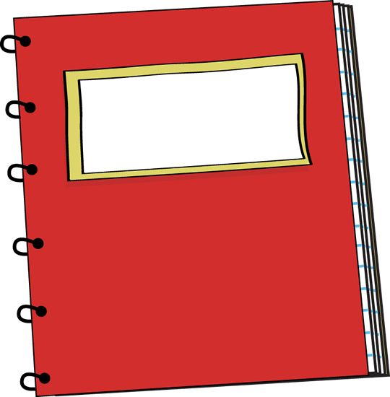
- “How long did it take you to get back into focus?”
- “How easy is it to get distracted? In school? At home?”
- “What were some ways that worked in getting you to focus again?”
- “Is it always a bad thing to be distracted?”

STEP 3. Students create a chart to monitor their behaviors. (3-4 mins)
- Students get out their MOSAIC notebooks

- On the top of the page write the title question as "At this moment, am I doing my work?"

- Below that question, divide the page by drawing a line down the center.

- The left side will be the date and the time column.

- The right side will be the Focus column, where students will answer if they are doing their work with either a 'yes' or a 'no'.

- Students can start with their first entry by writing the date and time. They all can start out with a yes!

STEP 4. Tell students how to use the chart. (2 mins)
- From now on, students can use this chart on their own to check on their own behavior and monitor if they are on task or not. It can be used in MOSAIC and in other classes.

- Tell students to add a note next to the entry whenever they choose 'no,' explaining the distractions that led them to go off task.

- Note: You can decide how often you want students to use this chart!

STEP 5. Make a plan for periodic check-ins. (1 min)
- Let students know when to use this chart and when you will follow-up with them.

FOLLOW UP

Use this chart as a tool to keep students keep focused in all classes and refer to the chart as much as possible. You may ask students if they notice any specific distractions they are noticing or certain days or times they need the most time to refocus. These distractions can also be reviewed when students are referred for discipline violations within the school.

