April

Appreciating Ourselves, Our School, and the World

Macintosh HD:Users:sarahdemarchena:Desktop:Mosaic_final_logo.eps

Year 3

**APRIL THEME**

**Connecting with Others and Being a Leader**

**APRIL VIrtue & SKills**

**Virtue:**

Compassionate Forgiveness

**Skills:**

Emotion Regulation & Empathy

**MOSAIC BY YEAR**

**MOSAIC Virtues & Skills**

Positive Purpose

Supporting Virtues Supporting Skills

1) Constructive Creativity 1) Emotional Regulation

2) Helpful Generosity 2) Communication

3) Optimistic Future-Mindedness 3) Empathy

4) Responsible Diligence 4) Social Problem Solving

5) Compassionate Forgiveness

and Gratitude

**MOSAIC Virtues & SKILLS By month**

|  |  |  |  |
| --- | --- | --- | --- |
| **Month** | **Theme** | **Virtue** | **Skills** |
| **September** | *Why are we here: Finding Our Positive Purpose* | Introduction to Positive Purpose | Communication & Social Problem Solving |
| **October** | *What Kind of Person Do I Want to Be?* | Virtue Identification | Skill  Identification |
| **November** | *Making Ourselves, School,*  *and World Better* | Constructive Creativity | Communication & Social Problem Solving |
| **December** | *Giving Back to Ourselves, School, and World* | Helpful Generosity | Communication & Social Problem Solving |
| **January** | *Planning for the Future* | Optimistic Future-Mindedness | Empathy & Social Problem Solving |
| **February** | *Showing Resilience and Overcoming Obstacles* | Responsible Diligence | Emotion Regulation & Social Problem Solving |
| **March** | *Appreciating Ourselves, Our School, and the World* | Compassionate Gratitude | Communication & Empathy |
| **April** | *Connecting with Others and Being a Leader* | Compassionate Forgiveness | Emotion Regulation & Empathy |
| **May** | *Looking Forward: Next Steps on the Journey* | Positive Purpose | Communication & Social Problem Solving |
| **June** | *Looking Back: What Have I Accomplished? What Have I Learned?* | All Virtues Summary | All Skills Integrated |

**MOSAIC** APRIL THROUGHLINE

**CONNECTING WITH OTHERS AND BEING A LEADER**

**How can we incorporate MOSAIC into**

**our class today?**

* Use self-calming skills to deal with stress.
* Practice empathy when others have upset us.
* Be understanding when you are in a leadership role.
* Macintosh HD:Users:sarahdemarchena:Desktop:Mosaic_final_logo.epsReach out to others and be forgiving so you can move on.

**MOSAIC in April**

Year 3 Curriculum

*8th grade students*

**April Activity 1: Intro to Compassionate Forgiveness**

Day 1: Introduce Theme and Ambassador Check-in

Day 2: Take a Brain Break  
Day 3: Apply Compassionate Forgiveness to Life

Days 4-5: Beliefs about Compassionate Forgiveness and Throughline

**April Activity 2: Combat Stress**

Day 6: Positive Self-Talk

Day 7: Positive Self-Talk Practice

**April Activity 3: Students Taking Action Together**

Day 8: A Role Model for Social Action and Reaching Future Dreams

Day 9-10: Human Rights

**April Activity 4: Bimonthly Reflection & Feedback**

Day 11: Reflection & Feedback for March/April

|  |  |
| --- | --- |
| **OBJECTIVE**  Students will take a position on “Connecting with Others and Being a Leader,” the new theme of the month. | **MATERIALS**   * MOSAIC Journals * April Throughline |
| **April Activity 1 Tips**   1. *Encourage students to relate theme to their own life and use personal examples.* 2. *examples during the activities.* | |

April Activity 1

***Intro to***

***Compassionate Forgiveness***

*Days 1 to 5*

**VIRTUE & SKILLS**

Compassionate Forgiveness

&

Emotion Regulation + Empathy

**“Introduction to Forgiveness” Overview**

**Day 1: Introduce Theme and Ambassador Check-in**

**Day 2: Take a Brain Break  
Day 3: Apply Compassionate Forgiveness to Life**

**Days 4-5: Beliefs about Compassionate Forgiveness and Throughline**

**DAY 1: *Introduce Theme and Ambassador Check-in***

**STEP 1. Ambassador Check-in**

* Introduce the theme and virtue by saying to students, ***“This month we will be focusing on the theme of ‘Connecting With Others and Being a Leader’, and the virtue of Compassionate Forgiveness.”***
* Tell students, ***“We will begin with an update from the Ambassadors on the Positive Purpose Projects.”***
* Prior to this class, please help Ambassadors prepare to give a brief update/progress report on the Positive Purpose Project. Their report can include:
* What is currently being worked on?
* What questions do you have that the class can give you help with?
* How can members of the class be helpful at this point in the project?
* Anything else you would like to communicate to the class about the Positive Purpose Projects?
* What questions do any class members have about the Project?

**STEP 2. Introduce Compassionate Leadership**

* Say, ***“Ambassadors are your class leaders. How do they show they are compassionate leaders?”*** Take two or three responses.
  + Some responses might include:
    - Compassionate leaders are understanding and forgiving when others make mistakes or have difficulties.
    - Leaders show compassion by being not being selfish and by thinking of others when making decisions
    - Compassionate leaders have empathy for those they work with and for those who are suffering from problems they are trying to help solve.
* ***“Please take out your MOSAIC Journals. Take 2-3 minutes to think of someone in your life that gives a good example of compassionate leadership to others. Please write down 3 qualities that this person has that makes them a leader that shows compassion.”***

**STEP 3. Forgiveness and Leadership** *(6-8 min)*

* Say, ***“Another part of compassionate leadership is that we are forgiving of those who disagree with us. So when some of you might disagree with how the Positive Purpose Project is going, it is important that the Ambassadors listen to you and not get defensive or lash out at you or ignore you because you disagree.”***
* ***“How do you think you should respond when Ambassadors disagree with your suggestions?”***
* Take a few responses and then ask, ***“How do you think group members, citizens, workers, and students should respond, in general, when leaders disagree with them?”***
* Make the point that emotion regulation is important to keeping your strong feelings calm when a leader disagrees with you, or when someone you are leading disagrees with you.
* Ask, “***What do you do to keep your emotions under control when someone disagrees with you about something you care about?”***
* Highlight useful emotion regulation strategies that students are already using.

**Day 2: *Take a Brain Break***

**STEP 1. Introduce Brain Break Activity**

* ***“Today, we are going to take a Brain Break. We are going to do an activity that will help your brain work a little better. It’s something you can try before a test or any situation where you want to be as alert and thoughtful as possible.”***
* ***“Scientists around the world have come to understand that our brains are affected by what goes on outside them.”***

**STEP 2. Lead Brain Break #1**

* ***“I will call out the instructions for you and keep a count for you.”***

**BRAIN BREAK**

* + ***Gently tap the top of your head with your fingertips 12 times***
  + ***Gently tap the sides of your head with your fingertips 12 times***
  + ***Gently tap the back of your head with your fingertips 12 times***
  + ***Tap the tops of your shoulders with your fingertips 8 times***
  + ***Grab your right shoulder with your right hand and rotate your arm backwards 4 times. Then, rotate forwards 4 times.***
  + ***Grab your left shoulder with your left hand and rotate your arm backwards 4 times. Then, rotate forwards 4 times.***
* Optional: Massage Circle between Brain Breaks
  + ***“Form a circle, front to back, so that everyone can reach the shoulders of someone right in front of them and everyone is included. Gently hold on to the shoulders of the person in front of you and massage the 12 times/for 15 seconds.”***

**STEP 3. Lead Brain Break #2**

* Repeat the same “Brain Break” process.
* ***“This time, as you are doing the Brain Break, be sure you are inhaling through your nose, breathing out through your mouth, and smiling while you are touching your head, shoulders, etc. Smiling is very important because it increases the flow of oxygen to our brains, which helps us be more Constructively Creative and Optimistically Future-Minded.”***

**STEP 4. Brain Break Debrief**

* ***“Did you feel any different between the first time and the second time you had a Brain Break? How did you feel different?”***
* ***“Remember to ask for a chance to do Brain Breaks before tests or any situation where you want to be at your most alert.”***

**FOLLOW UP**

* Arrange for Brain Breaks to be given before standardized and other testing.
* Be sure other staff members know about Brain Breaks in case your 8th graders ask to have them.
* Consider using Brain Breaks to begin faculty meetings or staff committee meetings or professional development or PLC sessions.

**DAY 3: *Apply Compassionate Forgiveness to Life***

**STEP 1. Listen to the Interview with George Takei**

[**http://www.wnyc.org/story/is-forgiveness-the-ultimate-test/**](http://www.wnyc.org/story/is-forgiveness-the-ultimate-test/)

**Time: 8 minutes**

**STEP 2. Discuss the George Takei Interview**

* ******Ask students to write in their MOSAIC Journals. Say, ***“Write in your journal two questions you had, and one emotion you felt when listening to George Takei’s story.”***
* Call on several students to share their questions, which may be related to “internment” and other historical elements to George Takei’s story.
* Then, ask students, ***“What were some of the feelings you had while listening to the story?”*** Take a few responses and be sure the Ambassadors respond.
* Then ask, ***“Why do you think George Takei was willing to forgive the government?”***
* ***“When in your life have you forgiven someone despite it being very hard to do so?”***
* ***“What helped you to be able to be forgiving?”***

**DAYS 4-5: *Beliefs about Compassionate Forgiveness and Throughline***

**STEP 1. Yes-No-Maybe about Compassionate Forgiveness**

* Tell students, ***“Today we are going to continue to respond to the story of George Takei and his family’s being imprisoned because they were Japanese-Americans and how he forgave the government for doing that. We will use our Yes-No-Maybe format for this.”***
* Read at least two of the statements below, and give your students the opportunity to determine if they believe the statement is true (Yes), not true (No) or either sometimes true or they are not sure (Maybe). Have your Ambassadors go to different groups to help them facilitate discussion and hear one-another’s perspectives:
  + - ***It is easy to show Compassionate Forgiveness to yourself for things you have done that you are not proud of.***
    - ***Saying that you forgive someone really does not make them feel better.***
    - ***Once someone does something wrong to you, you can never have a good relationship with them again.***
    - ***If you don’t forgive, the only one you are hurting is yourself.***
    - ***Create your own!***
* After each question, have a spokesperson for each group summarize the reasons why they chose, Yes, No, or Maybe. Give an opportunity for other group members to add if they wish.

**STEP 2. Reflect on Similarities and Differences**

* After you have completed the questions you have time for, let students take a seat and review answers that stood out.
* Ask students, ***“Was there anything that surprised you during the activity?***
* ***”***Point out that, ***“You had many different thoughts and there was not a single right answer.”***

**STEP 3. Introduce the Throughline Sheet**

* Say to students, ***“During the rest of this month, we will be using tools to plan for your positive future. This month’s Throughline Sheet reminds us to:*** 
  + ***1) Use self-calming skills to deal with stress.***
  + ***2) Practice empathy when others have upset us.***
  + ***3) Be understanding when you are in a leadership role.***
  + ***4) Reach out to others and be forgiving so you can move on.***
* ***We will learn to use these tools in more detail in the coming weeks.”***

* End the class by selecting a student to read the Throughline Sheet (displayed in a visible place in the classroom) aloud.

**FOLLOW UP**

* Throughout the month, provide specific, labeled praise for acts of leadership, forgiveness and gratitude in your MOSAIC class and in your other classes.
* Your class is now familiar with the MOSAIC Circle and Yes-No-Maybe formats. Whenever time is available, during MOSAIC or other classes, you can select videos or news articles from current events, or use aspects of books you are reading in any subject area and use a MOSAIC Circle or “Yes-No-Maybe” pedagogy to actively engage students in the topic.

**MOSAIC** APRIL THROUGHLINE

**CONNECTING WITH OTHERS AND BEING A LEADER**

**How can we incorporate MOSAIC into**

**our class today?**

* Use self-calming skills to deal with stress.
* Practice empathy when others have upset us.
* Be understanding when you are in a leadership role.
* Macintosh HD:Users:sarahdemarchena:Desktop:Mosaic_final_logo.epsReach out to others and be forgiving so you can move on.

April Activity 2

***Combat Stress***

*Days 6 to 7*

**VIRTUE & SKILLS**

Compassionate Forgiveness

&

Emotion Regulation + Empathy

|  |  |
| --- | --- |
| **OBJECTIVE**  Students will be able to use positive self-talk to combat stress. | **MATERIALS**   * Digital Projector/Computer * MOSAIC Journals * MOSAIC Projector Displays:   + Stress Thermometer   + Positive Self-Talk Statements |
| **April Activity 2 Tips**   1. *Encourage students to practice their positive self-talk skills throughout the day.* | |

**“Combat Stress” Overview**

**Day 6: Positive Self-Talk**

**Day 7: Positive Self-Talk Practice**

**DAY 6: *Positive Self-Talk***

**STEP 1. Introduce and Show Video**

* The affirmations in the video are presented in the **MOSAIC Projector Display: Positive Self-Talk**, should you want to use them with your students or if the video is unavailable.
* Say to the students, “***What we say to ourselves matters. When we talk positively to ourselves, we gain confidence; when we talk negatively to ourselves, we make it more likely we will fail.”***
* ***“So it’s important for our success- in tests, in relationships, in projects, in helping make our communities and the world better- to say positive things to ourselves, even when we have doubts.”***
* ***“Here is a video of many positive self-statements you can make to yourself. After you watch and listen, I will ask you to pick 5- or create 5- that you think will be most helpful to you when it comes to taking tests, and then another 5 (they could overlap) that you think will help you in your relationships and other parts of your life, and write them in your MOSAIC Journals.“***
* ***“After the video, we will use a MOSAIC Circle and have everyone share one statement that will help them stay confident during tests, and one statement that will help them be effective in relationships.”***

**Video** <https://www.youtube.com/watch?v=Rv3ejDal7vE>

(Stop at 3:22, “I am talented at many things,” to avoid any pop-ups)

**STEP 2. Review Structure of MOSAIC Circle As Needed** *(2-3 min.)*

* Review the structure of a MOSAIC Circle:
  + Gather students in a circle around the classroom (or some other configuration that allows students to see one-another), either standing or sitting.
  + Explain to students***, “In order to discuss the video we just watched, we will be using a MOSAIC Circle. In a MOSAIC Circle, we will respond to a specific question, and everyone in our class will get a turn to share their thoughts and feelings.”***
  + Ask students to recall the norms of a MOSAIC Circle. Be sure that the following norms are mentioned:
    - * ***What is said in the MOSAIC circle stays in the MOSAIC Circle***
      * ***One person talks at a time (depending on the needs of your classroom, it may be helpful to incorporate “Speaker Power” tools, such as a talking stick).***
      * ***Right to pass- students do not need to answer the question if they do not want to.***
      * ***No dialogue- MOSAIC Circle is not a time for discussion; it is a time to share your own thoughts and feelings.***

**STEP 3. Conduct MOSAIC Circles and Debrief** *(4-5 min.)*

* Conduct one MOSAIC Circle answering, ***“What positive self-statement did you select for preparing for a test?”***
* Conduct a second MOSAIC Circle answer, ***“What positive self-statement did you select for relationships or other areas of your life?”***
* After both Circles, ask:
* ***“Which statements came up most for tests? Which for relationships?”***
* ***“What similarities did you notice in both circles? What differences?”***
* ***How will you remember to use positive self-talk when you are in situations other than MOSAIC classes?”***
* NOTE: If necessary, the second circle and debrief can be continued as the start of the next lesson.**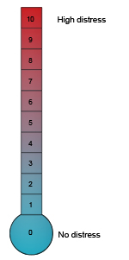**

(MOSAIC Projector Display)

**April Activity 2**

**Stress Thermometer**

(MOSAIC Projector Display)

**April Activity 2**

**Positive Self-Talk Statements**

I can do anything  
I am fearless  
I pursue my dreams with ease  
I am assertive   
I tell others how I feel  
I can stand up to anything  
I am very attractive  
I am bold and outgoing  
I can achieve anything I

desire  
I always stand up for myself

and my beliefs  
I always find a way to

succeed  
I am original  
I confidently meet any

challenge

I know I can achieve anything  
I can face anything that

confronts me  
I am a winner  
I am bold and brave  
I am fearless  
I am in control of my life  
I achieve massive success  
I believe in myself completely   
I can easily overcome any

failures or setbacks  
I speak my mind  
I respect myself deeply  
I am confident that I can

achieve anything  
I am strong  
I am talented at many things

**DAY 7: Positive *Self-Talk Practice***

**STEP 1. Practice Self-Talk** *(5-7 min)*

* Say, ***“Staying upset about things that happened in the past can hold you back from becoming your best self.”***
* Ask, ***“It also applies when we think too much about situations that were hard for us in the past and that are coming up again. What is an example of some situations that have been unpleasant or hard or frightening for you in the past that might come up again?”***
* Take a few responses. Be sure to prompt them to include taking tests and being bullied and wanting to avoid it.
* Then ask, ***“How do you feel when you think about these upcoming situations?”*** Take a few responses. Give them the opportunity to express their feelings in depth if they wish.
* Say to students, ***“When we are anticipating an unpleasant situation, we have strong feelings. Maybe we want to give up, avoid it, or lash out against it. In these moments, regulating our stress can help us to avoid more trouble and to move on, including facing the situation if we have no choice, and make the best of it. This is not easy, and so we need to practice regulating our stress, like working out at the gym. Every day this week, you will get to practice positive self-talk.***
* ***“First, think of something stressful in your life that is upcoming, and write down your Stress Thermometer number, from 0-10, in your MOSAIC Journal for how stressed you are feeling right now.***
* ***“Next, you will practice positive self-talk. That means you will speak to yourself in third person say encouraging statements to yourself that complete these sentences:”***
* ***“For the next 2 minutes, practice by saying:***
* ***\_\_\_\_\_\_\_\_ (your name) is \_\_\_\_\_\_\_\_\_\_\_\_\_\_\_\_\_\_\_\_\_\_\_***
* ***\_\_\_\_\_\_\_\_ (your name) can \_\_\_\_\_\_\_\_\_\_\_\_\_\_\_\_\_\_\_\_\_\_\_***
* ***\_\_\_\_\_\_\_\_ (your name) will \_\_\_\_\_\_\_\_\_\_\_\_\_\_\_\_\_\_\_\_\_\_\_***



* *(After 2 minutes)* ***“Now, write down in your MOSAIC Journal your stress thermometer (show handout) number for how you feel right now as you anticipate the upcoming situation.”***
* Have students share their numbers. Ask what challenges they experienced with positive self-talk and help them to address them.
* Ask them how they will remember to use positive self-talk in upcoming situations.

**FOLLOW UP**

* All school staff should know to remind students to use positive self-talk.

April Activity 3

**Students Taking**

**Action Together**

Days 8 to 10

**VIRTUE & SKILLS**

Compassionate Forgiveness

&

Emotion Regulation + Empathy

|  |  |  |
| --- | --- | --- |
| **OBJECTIVE**  Students will learn about a social action role model and be introduced to the United Nations Human Rights. | **MATERIALS**   * Chart paper or board spac * MOSAIC Journals * MOSAIC Projector Displays:   + Tererai Trent Article   + UN Human Rights Most Focused on Youth   + Example UN Rights Posters | |
| **April Activity 4 Tips**   1. *STAT (Activity 3) asks students to create UN Human Rights Posters. This may be a good project to showcase to the school or community. Ambassadors can play a role in organizing the event, if all of the eighth grade classrooms are interested.* 2. *Use your Ambassadors to lead or co-lead this activity.* | |

**“STAT” Overview**

**Day 8: A Role Model for Social Action and Reaching Future Dreams**

**Day 9-10: Human Rights**

**DAY 8: *A Role Model for Social Action and Reaching Future Dreams***

**STEP 1. Introduce Tererai Trent Video**

* ***“Today, we will watch a video about Tererai Trent. Tererai grew up in a cattle-herding family in rural Zimbabwe, where cultural practices and a war that liberated her country charted the course of her life. Men worked in mines, and women were expected to stay at home and take care of the family.”***
* ***“Tererai did not have the opportunity to go to school. She was forced to marry young and had three children by the time she was eighteen. But she never lost sight of her dreams: she wanted to be educated and taught herself to read and write from her brother’s schoolbooks.”***
* ***“The video tells the story of what happened next. Look for examples of her Compassionate Gratitude, Responsible Diligence, Helpful Generosity, Optimistic Future Mindedness, Empathy, and Problem Solving. Notice also how she communicates.”***

**STEP 2. Show Video**

<http://www.oprah.com/own-world/tererai-trent-returns-to-zimbabwe-to-share-her-story-video>

Length: 3:45

* NOTE: Use the MOSAIC Projector Display: Tererai Trent Article as a supplement to the video or to replace the video if you do not have access to the video.

**STEP 3. Lead Discussion about Video**

* After the video, ask students to, “***Write down your dreams for the future and place them in a safe place where you can look back on them in the future.”***
* Lead a discussion using these questions or others you prefer:

*Example Discussion Questions:*

* ***“Where did you see examples of Compassionate Gratitude, Responsible Diligence, Helpful Generosity, Optimistic Future Mindedness, Empathy, and Problem Solving in Tererai Trent’s story?”***
* ***“What did you notice about how Tererai Trent communicated her story? What did she do that you thought was most effective?”***
* ***“Why was education important to Tererai Trent?”***
* ***“What did she do to help others become better educated?”***
* ***“What can you do to help yourself become better educated?”***
* ***“What can you do to help others around you become better educated?”***
* ***“How did this video affect what you wrote down about your dreams for the future?”***

(MOSAIC Projector Display)

**April Activity 3**

**Tererai Trent Article**

**Tererai Trent: Turning Compassionate Gratitude into a Life of Empowerment Through Education**

From: <http://boldandfearless.me/dr-tererai-trent-why-this-woman-from-zimbabwe-became-oprahs-favorite-guest/>

For More Information: <http://www.tereraitrentinternational.org/>.

Rooted in humble beginnings, Tererai grew up in a cattle-herding family in rural Zimbabwe, in a country known as Rhodesia under colonial rule, where cultural practices and a war that liberated her country charted the course of her life. Men worked in mines, and women were expected to stay at home and take care of the family.

Tererai did not have the opportunity to go to school. Undeterred, she still dreamed of an education and determinedly taught herself to read and write from her brother’s schoolbooks. Despite being forced to marry young and have three children by the time she was eighteen, she never lost sight of her dreams.

As a young mother without a high school diploma, Tererai met a woman who would profoundly impact her life: Jo Luck, president and CEO of Heifer International. She told Tererai, “If you believe in your dreams, they are achievable.” With this inspiration and her own mother’s encouragement, Tererai wrote down her dreams of going to America for higher education, sealed them in a tin can, and buried them under a rock, ultimately redesigning the blueprint of her life.

Years later in 1998, Tererai moved with her family to Oklahoma where she eventually earned a bachelor’s degree in agricultural education. In 2003, Tererai received her master’s degree, and in December 2009, she obtained her doctorate from Western Michigan University. It was soon followed by a two-year commitment to work with Heifer International, which had sponsored her Ph.D.

**Dreams Fulfilled**

Tererai, who was featured in the book [*Half the Sky*](http://www.amazon.com/Half-Sky-Oppression-Opportunity-Worldwide/dp/0307387097/ref=sr_1_1/179-2808542-7319715?ie=UTF8&qid=1432125257&sr=8-1&keywords=book+half+the+sky), caught the attention of Oprah Winfrey who invited Tererai to [appear on her show](http://www.oprah.com/oprahshow/Tererai-Trents-Story-Video). Winfrey then surprised her with an award of $1.5 million to be used toward building a school in Zimbabwe. (Oprah eventually named Tererai her all-time favorite guest after 25 years of The Oprah Winfrey Show’s run on network TV.)

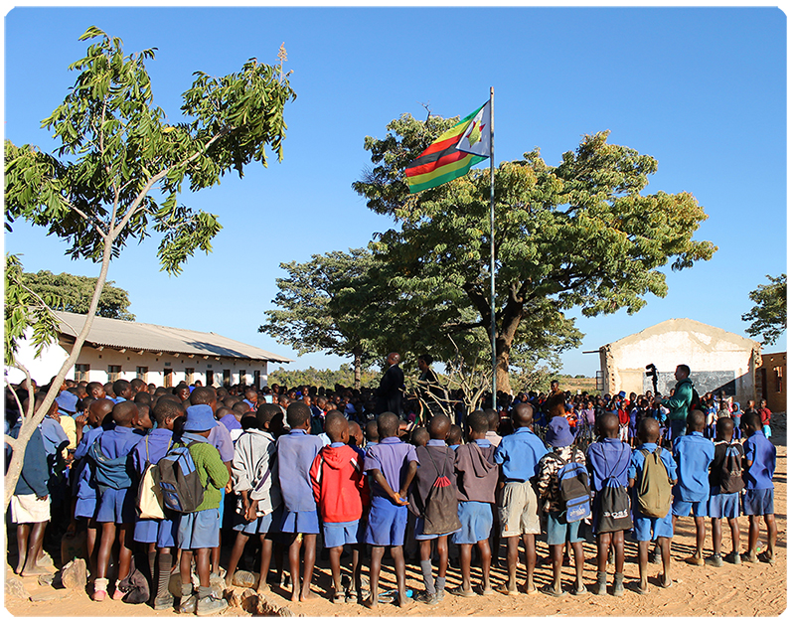Upon return to Zimbabwe, Tererai began work on Matau—the public school that Tererai attended more than forty years ago. Matau’s infrastructure was falling apart due to Zimbabwe’s economic crisis.

She says,  “It lacked desks, chairs, books, and skilled teachers. On average, five children shared a math textbook and four shared a seat and desk. Most children completed a seven-year school-cycle without access to a single textbook. This is what led me to rebuild the school and to give back to my community by improving the lives of women and girls.” The dire statistics that might discourage some served to fuel Tererai’s dreams.

In 2011, Tererai founded Tinogona Foundation, now known as [Tererai Trent International (TTI),](http://www.tereraitrentinternational.org/) whose mission is to provide universal access to quality education to children regardless of their gender or socio-economic backgrounds, as well as empower rural communities.

“Once, after a speaking engagement at The Agnes Irwin School in Pennsylvania, where I was addressing elementary school children, I wondered (as I often did), if I had made an impact on these young lives. I wondered if the young people had really grasped the depth of my message. And then a nine-year-old girl named Evelyn did something that would leave an indelible impression on me. This bright-eyed girl with a soft voice and amazing smile said to me, ‘can you wait here while I go and find the change in my backpack so you can build more schools?’ Those words affirmed for me that **girls are powerful and together, we can change the world,**” says Tererai.

[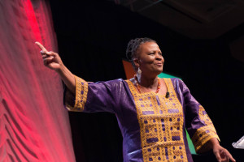](http://boldandfearless.me/wp-content/uploads/2015/05/Tererai-Speaking1.jpg)**Her Life Today**

Today, Tererai has an undying resolve to pay it forward, benefiting the community in which she grew up. “I am proof that educating girls can create a positive reaction in a community, and help break the cycle of poverty,” says Tererai. Alongside her quest to improve the quality of education in Zimbabwe, Tererai and her staff at TTI work tirelessly to increase employment, bolster the local economy, and build communities that can, and will, believe in themselves.

Gifted with natural charisma that inspires people from all walks of life, Dr. Trent’s compelling story motivates people to fight for their own dreams, as well as the dreams of others. Dr. Trent’s picture book, [*The Girl Who Buried Her Dreams in a Can*](http://www.tereraitrent.org/books-products/) (Viking Books), is based on her story of perseverance.

**Days 9-10: Human Rights**

**STEP 1. Introduce UN Human Rights**

* ***“The United Nations is an organization made up of all of the countries of the world. In addition to dealing with political issues and attempting to preserve peace in the world, the United Nations also works on behalf of human rights, including the rights of children.”***
* ***The MOSAIC Projector Display: UN Human Rights Most Focused on Youth shows you some of the human rights declared by the United Nations that are particularly important for young people throughout the world.***
* ***(***[**http://www.un.org/en/universal-declaration-human-rights/index.html**](http://www.un.org/en/universal-declaration-human-rights/index.html)**)”**

**STEP 2. Introduce Posters about UN Human Rights**

* ***“The next MOSAIC Projector Display: Example UN Rights Posters shows posters made by young people around the world telling about human rights they feel are most important.”***
* ***“Look up some additional information about the United Nations and its work at*** <http://www.un.org/en/about-un/>***”***

**STEP 3. UN Sustainable Development Goals Posters**

* ***“The UN has also made global goals for Sustainable Development. Those can be found here:***

[***http://www.un.org/sustainabledevelopment/sustainable-development-goals/***](http://www.un.org/sustainabledevelopment/sustainable-development-goals/)

* ***“Pick one of the UN Goals and work with two or three other students to make a Human Rights poster. You will have the rest of this class and the next MOSAIC class and any other time you would like to devote. You can also find out more about the UN goal you pick at the UN website.”***
* ***“Our Ambassadors will help us collect and display the posters around the school after they are completed. Perhaps we will arrange a program to present them to parents and the community.”***
* Optional: Arrange a school-wide program to present the posters to parents and the community.
* Note: You may want to coordinate this activity with your Arts teachers.

(MOSAIC Projector Display)

**April Activity 3**

**United Nations Human Rights Most Focused on Youth**

***Article 1***

All human beings are born free and equal in dignity and rights. They are endowed with reason and conscience and should act towards one another in a spirit of brotherhood.

#### **Article 4.**

No one shall be held in slavery or servitude; slavery and the slave trade shall be prohibited in all their forms.

#### **Article 5.**

No one shall be subjected to torture or to cruel, inhuman or degrading treatment or punishment.

#### **Article 7.**

All are equal before the law and are entitled without any discrimination to equal protection of the law.

#### **Article 18.**

Everyone has the right to freedom of thought, conscience and religion;

#### **Article 19.**

Everyone has the right to freedom of opinion and expression; this right includes freedom to hold opinions without interference and to seek, receive and impart information and ideas through any media and regardless of frontiers.

#### **Article 20.**

Everyone has the right to freedom of peaceful assembly and association.

#### **Article 23**

Everyone has the right to work, to free choice of employment, to just and favourable conditions of work and to protection against unemployment. Everyone, without any discrimination, has the right to equal pay for equal work.

#### **Article 25.**

(1) Everyone has the right to a standard of living adequate for the health and well-being of himself and of his family, including food, clothing, housing and medical care and necessary social services, and the right to security in the event of unemployment, sickness, disability, widowhood, old age or other lack of livelihood in circumstances beyond his control.  
(2) Motherhood and childhood are entitled to special care and assistance. All children, whether born in or out of wedlock, shall enjoy the same social protection.

#### **Article 26.**

(1) Everyone has the right to education. Education shall be free, at least in the elementary and fundamental stages. Elementary education shall be compulsory. Technical and professional education shall be made generally available and higher education shall be equally accessible to all on the basis of merit.  
(2) Education shall be directed to the full development of the human personality and to the strengthening of respect for human rights and fundamental freedoms. It shall promote understanding, tolerance and friendship among all nations, racial or religious groups, and shall further the activities of the United Nations for the maintenance of peace.

(MOSAIC Projector Display)

**April Activity 3**

**Example UN Rights Posters**

**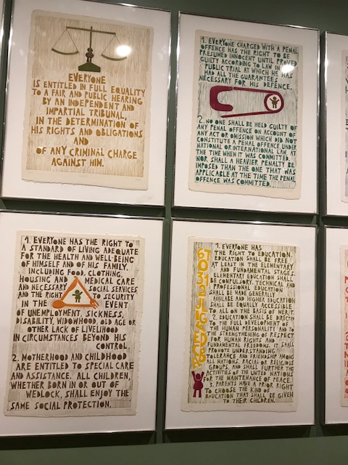**

**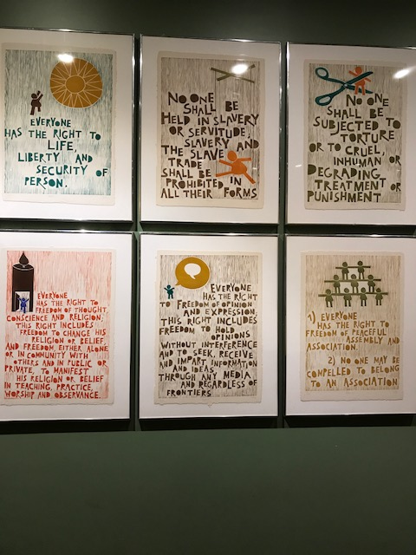**

April Activity 4

***Bi-monthly Reflection & Feedback***

*Day 11*

**VIRTUE & SKILLS**

Compassionate Forgiveness

&

Emotion Regulation + Empathy

|  |  |
| --- | --- |
| **OBJECTIVE**  Students will reflect on the previous month’s MOSAIC lessons and collectively provide feedback. | **MATERIALS**   * Projector * MOSAIC Journals * MOSAIC Teacher Handout:   + Bi-Monthly Feedback |
| **October Activity 5 Tips**  1. Completing the **MOSAIC Teacher Handout: Bi-Monthly Feedback** and sharing with your school’s MOSAIC instructional support team will help you and your school continue to make MOSAIC better and better. Additionally, saving a copy of this feedback for your own reference will help you to continuously improve MOSAIC in your classroom. | |

**“Bi-Monthly Reflection & Feedback” Overview**

**Day 11: *Reflection & Feedback for March/April***

**Day 11: *Reflection & Feedback for March/April***

**STEP 1. Introduce Reflection & Feedback Format** *(1-2 min)*

* Let students know that this is the last MOSAIC lesson of the month, and it’s time to get their feedback about the activities that took place this month.
* Remind students of the importance of their opinions and ideas about how to make things better, as good problem solvers.

**STEP 2. Students Give Feedback on March and April** *(3-5 min)*

* Prompt students to provide feedback about the activities from March and April. Be prepared to adjust the prompts if your MOSAIC scheduled changed due to testing.
* Say, ***“In March, we focused on the theme of Appreciating Ourselves, Our School and Our World. We did activities to practice communication and empathy, and we focused on Compassionate Gratitude. We also learned about the problem of clean water and worked on this problem during STAT.”***

*Discussion Questions:*

* + ***What were some things you liked about MOSAIC in March?***
  + ***How could those March lessons be better?***
* Say, ***“In April we focused on the theme of Connecting with Others and Being a Leader, and the virtue of Compassionate Forgiveness. We heard George Takei’s interview about the Japanese American internment and learned how to apply Compassionate Forgiveness to our lives. We practiced positive self-talk and we learned about Tererai Trent and we made posters to show United Nations Human Rights.”***

*Discussion Questions:*

* + ***What were some things you liked about MOSAIC in April?***
  + ***How could those April lessons be better?***

**STEP 3. Provide Reflection Activity Prompt** *(5-7 min)*

* Show **MOSAIC Projector Display: MOSAIC Reflection**.
* ******Have students respond to the scenario in their MOSAIC Journals. Tell students they have 5 minutes to respond.
* While students are writing in their MOSAIC Journals, complete the **MOSAIC Teacher Handout: Bi-Monthly Feedback**. Save this feedback and use to plan improvements for MOSAIC for the rest of the year. Additionally, if your school has a MOSAIC instructional support team, share this information with that team to inform wider MOSAIC improvements at the grade school levels.

**STEP 4. Students Share Reflection Responses** *(2-3 min)*

* Have students share their responses if there is time. You can also have students read each other’s responses if you need more time to complete your feedback.
* Do not press students if they are reluctant to share their opinions.

(MOSAIC Projector Display**)**

**April Activity 4**

**MOSAIC Reflection**

***Write your answer in your MOSAIC Journal:***

*An important test is coming up next week, but you don’t have enough time to study. Your friend suggests writing some of the important facts on your hand before the test. You know that it is wrong to cheat but you are also scared of failing the test.*

*What have you learned in MOSAIC that would help you figure out what to do?*

(MOSAIC Teacher Handout)

**Bi-Monthly Teacher Feedback**

School\_\_\_\_\_\_\_\_\_\_\_\_\_\_\_\_\_\_\_\_\_\_\_\_\_\_\_\_\_\_\_\_\_

MOSAIC Year (Grade Level): \_\_\_\_\_\_\_\_\_\_\_\_\_\_\_

1. **How much of the MOSAIC curriculum were you able to complete over the past two months?**

Not very much Somewhat Very much

1. **What did you like best about MOSAIC over the past two months (e.g., activities, student growth moments, etc.)?**
2. **What would you like to change about the MOSAIC program from the past two months?**
3. **What support(s) would help you teach MOSAIC most effectively?**